INTERIOR COATINGS SPECIFICATION
MASTER GUIDE SPECIFICATION
Specification Writer Edition | Website Reference

DOCUMENT CONTROL | VALUE
Category | Interior Coatings
CSI reference | CSI 09 91 23
Source treatment | Original technical content preserved; selection and editing guidance added
Publication status | Confirmed by Jazeera Paints

PURPOSE
This edition is structured so a specification writer can identify the project type, locate the area of use, select the applicable coating family, copy the retained specification text, edit only the highlighted project variables, and delete unused options before issue.

HOW TO USE THIS MASTER GUIDE
1. Select the project type in the Project Type Guide.
2. Select the area of use and finish in the System Selection Matrix.
3. Open the referenced Copy-Ready Specification Text block.
4. Edit yellow project variables, select one blue option, delete unused optional text, and stop at every red confirmation item.
5. Delete this guide text and all unused alternatives before issuing the project specification.
HIGHLIGHT AND TAG LEGEND
FORMAT | MEANING | ACTION
Copy-ready text | Text may be used without project-specific change | Copy as written after confirming the selected system
Project variable | A project-specific value is required | Edit [INSERT PROJECT REQUIREMENT] / [EDIT TO SUIT PROJECT]
Multiple choice | Only one alternative is to remain | Choose [SELECT ONE] and delete the other options
Optional clause | Clause may not apply | Delete [DELETE IF NOT REQUIRED]
Technical confirmation | Confirmed | Confirmed
Guide note | Instruction for the specification writer | Delete before final project issue
EDITING TOKENS
TOKEN | USE
[SELECT ONE] | Retain one option and delete the rest.
[INSERT PROJECT REQUIREMENT] | Insert the project value or criterion.
[EDIT TO SUIT PROJECT] | Adapt only the stated project variable.
[DELETE IF NOT REQUIRED] | Remove the full clause when not applicable.
[CONFIRM WITH JAZEERA PAINTS] | Confirmed
[TECHNICAL CONFIRMATION REQUIRED]

PROJECT TYPE AND RECOMMENDED PAINT SYSTEM GUIDE
Use this table only as a navigation guide. It does not create a new technical system. The applicable system must be selected from the retained source content and verified against the current TDS and project requirements.
PROJECT TYPE | STARTING SYSTEM GUIDE | PROJECT-SPECIFIC VARIABLES | CHECK BEFORE ISSUE
Residential | INT-01 / INT-03; use INT-02 / INT-04 for bathrooms and kitchens after confirmation | Room use; dry/wet classification; wall/ceiling; substrate; color; sheen; washability | Confirm wet-area and high-cleaning selections before issue
Schools & Education | INT-01 / INT-03; consider INT-05 / INT-06 where project criteria require | Traffic level; cleaning protocol; hygiene criteria; color; sheen | Select performance only from supported evidence and project requirements
Commercial & Offices | INT-01 / INT-03; consider INT-05 for circulation/high-touch areas | Area function; cleaning; finish; color; sheen; substrate | Coordinate with room data sheets and interior finish schedule
Hotels & Hospitality | INT-01 / INT-03; INT-07 for feature walls; wet areas require confirmation | Guest/service area; appearance; cleaning; wet-area exposure; mock-up | Approve decorative samples and wet-area systems
Hospitals & Healthcare | INT-05 / INT-06 where hygiene criteria apply; base areas INT-01 / INT-03 | Room classification; cleaning chemicals; microbial/fungal criteria; sheen; color | Owner infection-control criteria govern; confirm exact system
Government Buildings | INT-01 / INT-03 plus performance category required by project | Authority standard; area use; traffic; sustainability; finish schedule | Insert owner standards and delete unused alternatives
Other Projects | Choose by area-of-use matrix | Project type; exposure; substrate; performance; appearance | Seek Jazeera Paints technical confirmation where no direct match exists
PROJECT ADAPTATION RULES
• Retain the selected product name, system coat sequence, primer, intermediate coat, topcoat, coat count, thickness, coverage, application, performance evidence and standards exactly as confirmed.
• Edit only the project type, area/location, supported substrate, color, sheen, exposure, appearance and performance requirement fields identified as project variables.
• Where an owner or authority standard applies, insert it without deleting a stricter retained requirement unless technically approved.
• Delete every unused product, finish and optional clause before issue. Do not leave multiple alternatives in a project specification.
• Sustainability requirements must be tied to the selected rating system, credit, project scope and current supporting documentation.

SYSTEM SELECTION MATRIX
For readability, the requested system matrix is split into three synchronized tables. The System Code links the selection, coating build-up and project-variable information.
A. USE AND LOCATION
SYSTEM CODE | PROJECT TYPE | AREA OF USE | INT./EXT. | DRY/WET OR EXPOSURE | WALL/CEILING | SUBSTRATE | FINISH
INT-01 | All project types | Interior dry-area walls | Interior | Dry | Wall | Concrete / Plaster / Gypsum Board / Reinforced Decorative Gypsum / Masonry | Smooth
INT-02 | Residential / Hospitality / Healthcare / Other | Bathrooms and kitchens – painted wall zones | Interior | Wet | Wall | [SELECT ONE from supported substrates] | Smooth
INT-03 | All project types | Interior dry-area ceilings | Interior | Dry | Ceiling | Concrete / Plaster / Gypsum Board / Reinforced Decorative Gypsum / Masonry | Smooth
INT-04 | Residential / Hospitality / Healthcare / Other | Bathrooms and kitchens – ceilings | Interior | Wet | Ceiling | [SELECT ONE from supported substrates] | Smooth
INT-05 | Schools / Commercial / Hospitality / Healthcare / Government | High-traffic / high-cleaning areas | Interior | Dry or wet | Wall | [SELECT ONE from supported substrates] | Smooth
INT-06 | Healthcare / Schools / Government / Other | Areas requiring microbial or fungal resistance | Interior | Project-specific | Wall / Ceiling | [SELECT ONE from supported substrates] | Smooth
INT-07 | Residential / Commercial / Hospitality / Government | Feature walls and design-led interiors | Interior | Dry unless TDS confirms otherwise | Wall | Use exact selected TDS system | Special / Decorative
INT-08 | Residential / Commercial / Hospitality / Government | Textured interior walls | Interior | Project-specific | Wall | Use exact selected TDS system | Textured
INT-09 | Car parks / Infrastructure / Other | Interior concrete and masonry requiring anti-carbonation performance | Interior | Project-specific | Wall / Ceiling | Concrete / Cement / Masonry | Smooth

SYSTEM SELECTION MATRIX — CONTINUED
B. COATING BUILD-UP
SYSTEM CODE | PRIMER | INTERMEDIATE COAT | TOPCOAT | NUMBER OF COATS | THICKNESS
INT-01 | 1 coat water-based primer based on acrylic polymer (or suitable Jazeera primer) | 2 coats Acrylic Interior putty | 2 coats Acrylic topcoat | 1 + 2 + 2 | Putty: 100–200 micron each coat; Topcoat: 30–75 micron each coat
INT-02 | [CONFIRM WITH JAZEERA PAINTS] | [CONFIRM WITH JAZEERA PAINTS] | [SELECT ONE from supported interior categories] | Use selected TDS system | Use selected TDS system
INT-03 | Use applicable selected system | Use applicable selected system | [SELECT ONE] Plain Emulsion / Cover Ceiling Defects category | Use selected TDS system | Use selected TDS system
INT-04 | [CONFIRM WITH JAZEERA PAINTS] | [CONFIRM WITH JAZEERA PAINTS] | [SELECT ONE after technical confirmation] | Use selected TDS system | Use selected TDS system
INT-05 | Use exact selected TDS system | Use exact selected TDS system | [SELECT ONE] High Performance / supported washable topcoat | Use selected TDS system | Use selected TDS system
INT-06 | Use exact selected TDS system | Use exact selected TDS system | [SELECT ONE] Antimicrobic Interior Topcoat | Use selected TDS system | Use selected TDS system
INT-07 | Use exact selected TDS system | Use exact selected TDS system | [SELECT ONE] Special Effect Interior Topcoat | Use selected TDS system | Use selected TDS system
INT-08 | Use exact selected TDS system | Use exact selected TDS system | [SELECT ONE] Interior Texture Topcoat | Use selected TDS system | Use selected TDS system
INT-09 | Use exact selected TDS system | Use exact selected TDS system | [SELECT ONE] Anticarbonation Interior Topcoat | Use selected TDS system | Use selected TDS system

SYSTEM SELECTION MATRIX — CONTINUED
C. FINISH, PERFORMANCE AND PROJECT VARIABLES
CODE | SHEEN | COLOR | COVERAGE | PERFORMANCE REQUIREMENTS | RECOMMENDED PRODUCT / CATEGORY | RELATED CLAUSE | PROJECT-SPECIFIC VARIABLES
INT-01 | [SELECT ONE] | [INSERT PROJECT REQUIREMENT] | Use selected TDS | Washable emulsion; project-specific requirements to be inserted | Plain Emulsion Interior Topcoats | Part 2 – Interior Paint Schedule; INT-CR-01 | Room/area, substrate, color, sheen, selected product, project performance
INT-02 | [SELECT ONE] | [INSERT PROJECT REQUIREMENT] | Use selected TDS | Moisture / mould / washability requirements [EDIT TO SUIT PROJECT] | Technical selection required | INT-CR-03; Technical Evidence Register | Wet-area definition, direct-water exposure, ventilation, performance criteria
INT-03 | [SELECT ONE] | [INSERT PROJECT REQUIREMENT] | Use selected TDS | Ceiling appearance and defect-hiding requirement [EDIT TO SUIT PROJECT] | Plain Emulsion / Cover Ceiling Defects | Part 2; Technical Evidence Register; INT-CR-01 | Ceiling substrate, finish, color, sheen, defect-hiding requirement
INT-04 | [SELECT ONE] | [INSERT PROJECT REQUIREMENT] | Use selected TDS | Moisture / mould resistance [EDIT TO SUIT PROJECT] | Technical selection required | INT-CR-03; Technical Evidence Register | Humidity, condensation, ventilation, substrate, performance criteria
INT-05 | [SELECT ONE] | [INSERT PROJECT REQUIREMENT] | Use selected TDS | Washability / scrub / stain / hygiene [INSERT PROJECT REQUIREMENT] | High Performance Interior Topcoats | Technical Evidence Register; INT-CR-03 | Cleaning protocol, test criteria, sheen, color, selected performance
INT-06 | [SELECT ONE] | [INSERT PROJECT REQUIREMENT] | Use selected TDS | Microbial / fungal performance [INSERT PROJECT REQUIREMENT] | Antimicrobic Emulsion Interior Topcoats | Technical Evidence Register; INT-CR-03 | Area classification, hygiene protocol, required test/standard, sheen, color
INT-07 | As selected effect | [INSERT PROJECT REQUIREMENT] | Use selected TDS | Approved sample / mock-up [EDIT TO SUIT PROJECT] | Special Effect Interior Basecoat / Topcoats | Part 2; Technical Evidence Register; INT-CR-02 | Effect, pattern, color, sample, application method, approved specialist
INT-08 | As selected texture | [INSERT PROJECT REQUIREMENT] | Use selected TDS | Texture / pattern / mock-up [EDIT TO SUIT PROJECT] | Interior Texture Topcoats | Technical Evidence Register; INT-CR-03 | Texture profile, pattern, color, sample, application method
INT-09 | [SELECT ONE] | [INSERT PROJECT REQUIREMENT] | Use selected TDS | Anti-carbonation / crack-bridging / permeability [INSERT PROJECT REQUIREMENT] | Anticarbonation Interior Topcoats | Technical Evidence Register; INT-CR-03 | Exposure, required tests/criteria, substrate condition, color, sheen

INTERIOR COATINGS
PART 1 - GENERAL
1.1 SECTION INCLUDES

- Painting materials complete with primers, sealers, fillers, stains and finish coats applied for interior areas as indicated on Drawings and as specified herein.

- Anti-static painting suitable for electrical rooms, low current rooms and server rooms.

1.2 REFERENCES

- SASO – Saudi Arabian Standards Organization

SASO 321 Industrial safety and health regulations - Hazardous materials - Paints - Part 1: Spray finishing using flammable and combustible materials
SASO 470 Paint and varnishes.
SASO 471 Ready mixed oil-based paints for use on concrete and masonry.
SASO 472 Paints and varnishes – Gloss enamel (For interior and exterior surfaces)
SASO 473 Paints and varnishes.
SASO 474 Paints and varnishes – Examination and preparation of samples for testing.
SASO 475 Paints and varnishes – Determination of the effect of heat.
SASO 476 Paints and varnishes - Determination of the effect of heat
SASO 477 Paints and varnishes – Scratch test.
SASO 478 Paints and varnishes – Determination of resistance to water – Water immersion method.
SASO 592 Paints and varnishes - Surface-Drying test - Ballotini method
SASO 593 Paints and varnishes - Bend test - (Cylindrical mandrel)
SASO 780 Paints and varnishes - Determination of resistance to humidity (Continuous condensation).
SASO 1188 Methods of test for paints and varnishes: Determination of hard drying time.
SASO 810 Paints and varnishes - Sampling equipment.
SASO 861 Methods of test for paints and varnishes: Preparation of test panels before coating.
SASO 868 Methods of test for paints and varnishes: Determination of flash-point (Closed cup method).
SASO 817 Priming paints.
SASO 818 Alkyd based undercoating paints for general purposes.
SASO 943 Paints and varnishes - Methods of testing glass beads for road marking paints

- ASTM - American Society for Testing and Materials

ASTM D 16 Standard Definitions of Terms Relating to Paint, Varnish, Lacquer, and Related Products
ASTM D 562 Consistency of Paints Using the Stromer Viscometer
ASTM D 2833 Standard Index of Methods for Testing Architectural Paints and Coatings
ASTM D 3276 Standard Guide for Painting Inspectors (Metal Substrates)
ASTM D 3927 Standard Guide for State and Institutional Purchasing of Plant
ASTM E 84 Surface Burning Characteristics of Building Material

1.3 SUBMITTALS
A. Product Data: Submit manufacturers technical information including instructions for thinning, mixing, curing and touch-up.
B. Manufacturer's standard color charts.
C. Test Reports and certificates of compliance.
D. Samples: Prior to beginning work, furnish color chips for surfaces to be painted. Submit samples for the Engineer review of color and finish. Provide a listing of material and application for each coat of each final sample.
1. On 300 mm x 300 mm hardboard, provide 2 samples of each color and material, with final finish to simulate actual conditions. Re-submit samples as requested by Engineer until acceptable sheen, color and finish is achieved.
2. On wood surfaces, provide 2 samples 100 x 200 mm of natural and stained wood finish on actual wood types. Label and identify each as to location and application.
3. On concrete masonry, provide two 100 mm square samples of masonry for each type of finish and color, defining filler, prime and finish coat.
4. On actual wall surfaces and other exterior and interior building components, duplicate painted finishes of prepared samples. Provide full-coat finish samples on at least 9 m² of surface, as direct, until required sheen, color and final finish is obtained; simulate finished lighting conditions for review of in-place work.
5. Final acceptance of colors will be from samples applied on the job.

1.4 TRANSPORTATION, HANDLING AND STORAGE

A. Deliver materials to job site in manufacturer's original new and unopened packages and containers bearing manufacturer's name and label, and following information:
- Name or title of material.
- Manufacturer's stock number and date of manufacture.
- Manufacturer's name.
- Contents by volume, for major pigment and vehicle constituents.
- Thinning instructions.
- Application instructions.
- Color name and number.

B. Store materials not in actual use in tightly covered containers in a well-ventilated area and protect from moisture, direct sunlight and temperatures below 10oC and above limits recommended by the manufacturer. Maintain containers used in storage of paint in clean conditions, free of foreign materials and residue.
C. Keep storage area neat and orderly. Remove oily rags and waste daily. Take all precautions to ensure that workmen and work areas are adequately protected from fire hazards and health hazards resulting from handling, mixing and application of paints.

1.5 QUALITY ASSURANCE
A. Single Source Responsibility:
Provide sealers, fillers, stain, undercoats, and finish coats produced by the same manufacturer. Use only thinners and other additives approved by the paint manufacturer and only within the manufacturer's recommended limits.
B. Coordination of Work:
Review other Sections of these Specifications in which prime paints are to be provided to ensure compatibility of the complete coating system with the various substrates. Upon request from other trades, furnish information on the characteristics and requirements of finish materials provided to ensure that compatible prime coats are used.
C. Material Quality:
Provide manufacturer's best-quality trade-sale paint materials of the various coating types specified. Paint material containers that do not display the manufacturer's product identification will not be acceptable.
1.6 JOB CONDITIONS
A. General Conditions:
Do not apply paint in areas where excessive dust, dirt, or airborne contaminants may settle on wet surfaces. Maintain suitable environmental conditions during application and drying. Comply with the paint manufacturer's recommendations regarding application, ventilation, and drying temperatures.
B. Water-Based Paints:
Apply water-based paints only when the moisture content of the substrate does not exceed 12% and the temperature of the surfaces to be painted and the surrounding air is between 10°C and 32°C, unless otherwise permitted by the paint manufacturer's printed instructions.
C. Solvent-Thinned Paints:
Apply solvent-thinned paints only when the moisture content of the substrate does not exceed 4% and the temperature of the surfaces to be painted and the surrounding air is between 7°C and 35°C, unless otherwise permitted by the paint manufacturer's printed instructions.
D. Relative Humidity:
Do not apply paint when the relative humidity exceeds 85%, or to damp or wet surfaces, unless otherwise permitted by the paint manufacturer's printed instructions. Provide adequate ventilation during application and drying to facilitate proper film formation and minimize accumulation of vapors.

PART 2 – PRODUCTS
2.1 MATERIALS
A. Material Quality
- Provide premium-grade interior architectural paint and coating materials of the types specified, manufactured by an acceptable and established coating materials manufacturer. Products shall be specifically formulated and suitable for the intended substrate, interior environment, and service requirements.
- Paints, primers, and coatings shall be supplied in the manufacturer's original, unopened, sealed containers, clearly identified with the manufacturer's name, product name, product identification, batch or lot number, and other applicable information.
- Materials shall be standard products regularly manufactured and commercially available from the manufacturer. Materials that are unidentified, improperly labeled, expired, damaged, or not supplied in the manufacturer's original containers will not be acceptable.
- Primer, intermediate, and finish coats shall be mutually compatible and, unless otherwise approved, shall be products manufactured by the same manufacturer and form part of the manufacturer's recommended coating system.

B. Paint Systems
- Refer to the Painting Schedule at the end of this Section for the specified interior paint and coating systems.
- Provide complete coating systems, including surface preparation, primers, intermediate coats, and finish coats, in accordance with the Painting Schedule and the coating manufacturer's written recommendations.
- Coating systems shall be suitable for interior architectural applications and shall provide appropriate resistance to normal interior conditions, including washing, wet cleaning, abrasion, scuffing, staining, and routine maintenance, as applicable to the specified area and finish.
- Coating systems shall be selected according to the requirements of the specific interior area, including general occupied spaces, high-traffic areas, wet or humid areas, kitchens, service areas, and other areas subject to increased cleaning or moisture exposure, where applicable.
C. Paint Colors
- Color: Match the Engineer's approved color samples.
- Provide uniform color, sheen, and appearance throughout each continuous painted surface. Final colors shall be subject to the Engineer's approval before commencement of finish-coat application.
- Where different colors or finishes are specified, provide clean, straight, and sharply defined lines at junctions between adjacent colors and finishes.
- Provide the specified sheen and finish consistently throughout each designated area. Touch-up materials shall match the approved finish in color, sheen, and appearance.

Technical Confirmation – Interior Painting
For the interior version, I recommend replacing your previous confirmation checklist with the following:
- Interior suitability: Confirm that the proposed products are specifically suitable for interior architectural applications and the intended areas of use.
- Substrate compatibility: Confirm compatibility with the actual substrates, such as concrete, cement render, plaster, gypsum board, drywall, masonry, wood, and previously painted surfaces, as applicable.
- Moisture resistance: Confirm suitability for areas exposed to moisture or humidity, such as bathrooms, kitchens, laundries, and service areas, where applicable.
- Washability / scrub resistance: Verify claims for washability, wet scrubbing, and abrasion resistance against the manufacturer's TDS and applicable test data, particularly for high-traffic and frequently cleaned areas.
- Stain resistance: Where stain resistance is specified or claimed, verify the performance against the manufacturer's technical documentation and applicable test data.
- Color and sheen retention: Confirm that the proposed product provides the required color and appearance stability under the expected interior lighting and service conditions.
- VOC / indoor air quality: Where required by the project, confirm VOC content and any applicable indoor-air-quality or low-emission requirements against the current TDS, SDS, certifications, or test reports.
- Mildew/fungal resistance: Where products are proposed for humid areas, verify any mildew or fungal resistance claims using the manufacturer's supporting technical documentation.
- Fire performance: If a fire-rating requirement is specified, verify that the complete proposed system and substrate configuration has the required test classification. Do not automatically carry ASTM E84 Class A from another specification without confirming that it is applicable to the particular interior coating/system.
- ANSI Z535.1 safety colors: Confirm whether safety colors are actually required by the project. They should not be included as a general interior architectural-paint requirement unless the specification specifically covers safety identification or color coding.
- Dark colors: Confirm any limitations associated with dark or high-chroma colors, including coverage, number of coats, color uniformity, and touch-up requirements. Unlike exterior façades, solar heat absorption is generally not a primary consideration for ordinary interior paint, unless the interior is subject to unusual heat or direct solar exposure.

PART 3 – EXECUTION
3.1 EXAMINATION
A. Examine substrates and conditions under which painting work is to be performed. Do not proceed with painting until unsatisfactory conditions have been corrected.
B. Verify that surfaces are properly prepared, dry, clean, sound, and free from dust, dirt, grease, oil, efflorescence, loose material, laitance, and other contaminants that may adversely affect coating adhesion or performance.
C. Verify that moisture content and other substrate conditions are within the limits recommended by the paint manufacturer for the specified coating system.
D. Verify compatibility of existing coatings, sealers, primers, and other materials with the specified coating system before application.
E. Notify the Engineer of conditions that may adversely affect the appearance, adhesion, or performance of the coating system. Do not commence painting until such conditions have been corrected.

3.2 PREPARATION
A. Protect adjacent surfaces, finishes, fixtures, fittings, furniture, equipment, and other items from damage, staining, or paint splatter.
B. Remove dirt, dust, grease, oil, wax, efflorescence, mildew, loose paint, and other contaminants from surfaces to be painted using methods recommended by the coating manufacturer.
C. Fill cracks, holes, joints, depressions, and other surface imperfections with suitable fillers or patching compounds compatible with the specified coating system.
Cracks Treatment
Filling Range | Jazeera Fillers
Up to 1 cm | JAZEERA CRACK FILLER / Two-components filler
up to 2 cm wide and 2 cm depth. | JAZEERA ULTIMATE / Light weight filler
0.5–2 mm | JAZEERA EPOXY CRACK FILLER 400 / Two-component, solvent free filler, based on epoxy polyamide cured
up to 4 cm width and 8 cm depth | JAZEERA UNIQUE FILLER / Light weight, two components, solvent free epoxy filler
Cement Joint treatment | JAZEERA UNIQUE JOINTS / Two component epoxy based light weight filler, specially formulated to seal joints between cement boards and concrete panels
Gypsum Joint treatment | JAZEERA GYPSONEAT / Water borne putty based on special type of emulsion and modifiers, specially used for leveling and smoothing both vertical and horizontal gypsum surfaces

D. Sand or otherwise abrade surfaces as required to provide a smooth, sound, and properly prepared substrate suitable for coating application.
E. Remove loose, peeling, blistered, or poorly adhered existing coatings. Feather edges of remaining sound coatings to provide a smooth transition.
F. Prepare previously painted surfaces in accordance with the coating manufacturer's recommendations to ensure adequate adhesion of the new coating system.
G. Prime bare, porous, patched, repaired, or otherwise uncoated surfaces with the specified primer compatible with the substrate and finish coating.
H. Do not apply coatings over surfaces contaminated with moisture or other conditions that could adversely affect adhesion or coating performance.

3.3 APPLICATION
A. Apply paints and coatings in accordance with the manufacturer's written instructions and the requirements of this Section.
B. Apply coatings by brush, roller, spray, or other approved method appropriate for the specified product, substrate, and finish.
C. Apply each coat uniformly and evenly, free from runs, sags, drips, curtains, brush marks, roller marks, excessive spray, or other defects.
D. Apply successive coats only after the preceding coat has adequately dried and cured in accordance with the manufacturer's recommended recoat interval.
E. Apply sufficient coats to achieve the specified color, opacity, uniformity, and finish. Additional coats shall be applied where necessary to obtain complete and uniform coverage.
F. Maintain uniform color, sheen, texture, and appearance throughout continuous surfaces. Avoid lap marks and visible variations caused by application methods.
G. Maintain clean and sharply defined lines at corners, edges, junctions, openings, and interfaces between different colors or finishes.
H. Do not thin paints or coatings except where specifically permitted by the manufacturer's written instructions. Use only approved thinners and additives and within the manufacturer's recommended limits.
I. Do not apply coatings when environmental or substrate conditions are outside the limits specified by the manufacturer.
J. Provide adequate ventilation during application and drying of coatings, particularly when solvent-containing products are used.

3.4 FIELD QUALITY CONTROL
A. Inspect completed painted surfaces for uniformity of color, sheen, coverage, adhesion, and overall appearance.
B. Correct defects including runs, sags, drips, pinholes, holidays, cracking, blistering, peeling, excessive brush or roller marks, uneven sheen, and color variations.
C. Touch up damaged or defective areas using compatible materials and application methods that produce a finish matching the surrounding surface.
D. Where touch-up cannot produce an acceptable uniform appearance, repaint the affected area or complete surface as directed by the Engineer.
E. The Engineer may require additional coats where the specified coverage, color, opacity, or finish has not been achieved.

3.5 CLEANING
A. Remove masking materials, protective coverings, paint splatters, drips, and other debris resulting from the painting work.
B. Clean adjacent surfaces, fixtures, fittings, glass, floors, and other items affected by the painting operations without damaging completed finishes.
C. Remove temporary protection after completion of painting and when approved by the Engineer.
D. Leave completed areas clean, orderly, and ready for occupancy.

3.6 PROTECTION
A. Protect completed painted surfaces from damage, dust, dirt, moisture, and other contaminants until the coatings have fully dried and cured.
B. Do not permit subsequent construction activities to damage or contaminate completed painted surfaces.
C. Repair or replace damaged painted surfaces to the satisfaction of the Engineer using compatible materials and approved application methods.
D. Maintain required environmental conditions during the drying and curing period in accordance with the coating manufacturer's written recommendations.
Technical confirmation points for Part 3
Before public issue, I would specifically confirm:
- Substrate moisture limits against the actual product TDS.
- Application temperature and RH limits against each coating manufacturer's requirements.
- Recoat/drying times for the specified products.
- Surface preparation requirements for concrete, plaster, gypsum board, masonry, wood, and previously painted surfaces, as applicable.
- Primer compatibility with each specified finish coat.
- Number of coats and coverage rates against the Painting Schedule/TDS.
- VOC and ventilation requirements, particularly for solvent-based interior products.
- Washability/scrub resistance where required for high-traffic or frequently cleaned areas.
- Any fire-performance requirement, ensuring the claimed classification applies to the actual coating system and substrate.

COPY-READY SPECIFICATION TEXT
The green text below reproduces the source schedule/execution wording for direct use. Complete all yellow fields, select one blue option, delete unused text, and resolve red items before issue. Product-specific values remain in the retained Technical Evidence Register and require system confirmation where marked.
INT-CR-01 — INTERIOR PLAIN / SMOOTH FINISH
PROJECT FIELD | SELECTION
Project | [INSERT PROJECT REQUIREMENT]
Area of use | [SELECT ONE: Dry-area wall / Wet-area wall / Dry-area ceiling / Wet-area ceiling / High-cleaning area / Special-performance area]
Substrate | [SELECT ONE: Concrete / Plaster / Gypsum Board / Reinforced Decorative Gypsum / Masonry]
Finish | [SELECT ONE: Plain / Smooth Finish]
Color | [INSERT PROJECT REQUIREMENT]
Sheen / texture | [SELECT ONE]
Performance | [EDIT TO SUIT PROJECT]

Interior Smooth Finish
A. Cementitious Materials: concrete, cement, and brick surfaces:
a. Water based, Silk Smooth Finish “Dry Area” :
1) Skim coat and leveling: 2 coats of JAZEERA MATRIX ; single component, polymer modified, water resistant, fine cementitious mortar for leveling and smoothing of all interior surfaces including concrete surfaces, pillars and interior plastered surfaces for walls and ceilings . / DFT 1-2 mm / VOC <1 g/L
2) Prime Coat: 1 coat of JAZEERA GREEN PRIME ; water borne primer based on special acrylic polymer, highly durable and alkali resistant.
Volume Solid 34 ± 2 % / DFT 25-35 micron / VOC <1 g/L
3) Putty: 2 coats of JAZEERA GREEN PUTTY : Water borne putty, for leveling and smoothing interior architectural surfaces.
4) Topcoat: 2 coats of JAZEERA NOVEL: 100% pure acrylic water based paint with smooth silk effect, based on unique self-cross-linking technology to offer superior adhesion and crack bridging ability, washability with water and soap, easy stain and dirt removal, flame spread resistance property as well as excellent resistance to microbes in addition to high chemical resistance, For luxurious and high end areas where high stain resistance and hygienic properties are required.
Volume Solid 40 % / DFT 30-50 micron / VOC <1 g/L

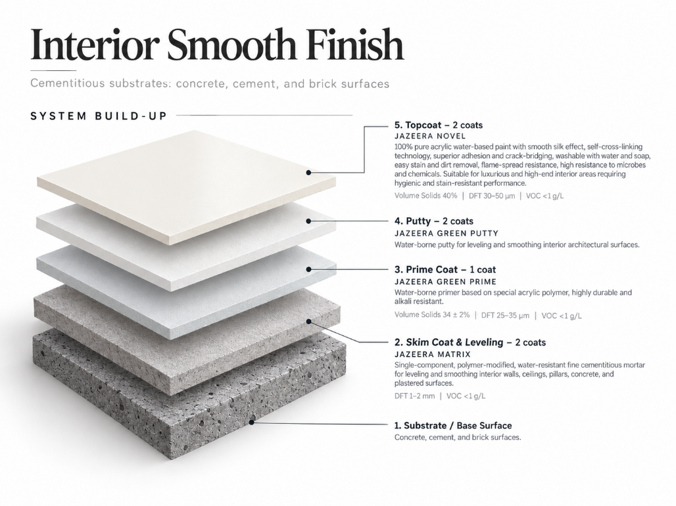

b. Water based, Antimicrobic Silk Smooth Finish “Wet Area” :
1) Skim coat and leveling: 2 coats of JAZEERA MATRIX ; single component, polymer modified, water resistant, fine cementitious mortar for leveling and smoothing of all interior surfaces including concrete surfaces, pillars and interior plastered surfaces for walls and ceilings . / DFT 1-2 mm / VOC <1 g/L
2) Prime Coat: 1 coat of JAZEERA GREEN PRIME ; water borne primer based on special acrylic polymer, highly durable and alkali resistant.
Volume Solid 34 ± 2 % / DFT 25-35 micron / VOC <1 g/L
3) Putty: 2 coats of JAZEERA GREEN PUTTY : Water borne putty, for leveling and smoothing interior architectural surfaces.
4) Topcoat: 2 coats of JAZEERA GREEN ANTIMICROBIC: Silk emulsion topcoat paint, based on 100% pure acrylic polymer emulsion, designed to provide exceptional properties in scrub-ability, washability and excellent resistance to microbe’s growth in addition to anti-flame spread and hygienic properties are required.
Volume Solid 35 ± 2 % / DFT 30-50 micron / VOC 5.4 g/L

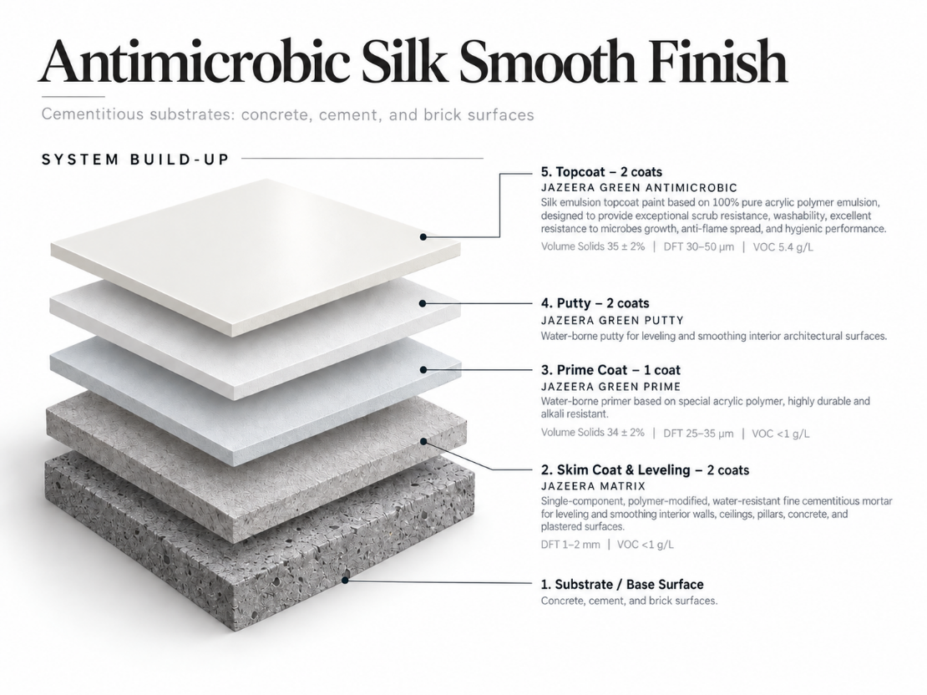

c. Solvent based, Enamel Semi gloss Smooth Finish “Wet Area” :
1) Skim coat and leveling: 2 coats of JAZEERA MATRIX ; single component, polymer modified, water resistant, fine cementitious mortar for leveling and smoothing of all interior surfaces including concrete surfaces, pillars and interior plastered surfaces for walls and ceilings . / DFT 1-2 mm / VOC <1 g/L
2) Prime Coat: 1 coat of JAZEERA GREEN PRIME ; water borne primer based on special acrylic polymer, highly durable and alkali resistant.
Volume Solid 34 ± 2 % / DFT 25-35 micron / VOC <1 g/L
3) Putty: 2 coats of JAZEERA GREEN PUTTY : Water borne putty, for leveling and smoothing interior architectural surfaces.
Volume Solid 50% / DFT 100-200 micron each coat / VOC <1 g/L
4) Topcoat: 2 coats of JAZEERA JAZETAL SEMI GLOSS: semi-gloss enamel topcoat paint, based on modified alkyd resin. excellent leveling, high durability and excellent resistance to water and moisture.
Volume Solid 47.25 % / DFT 35 micron / VOC 360 g/L

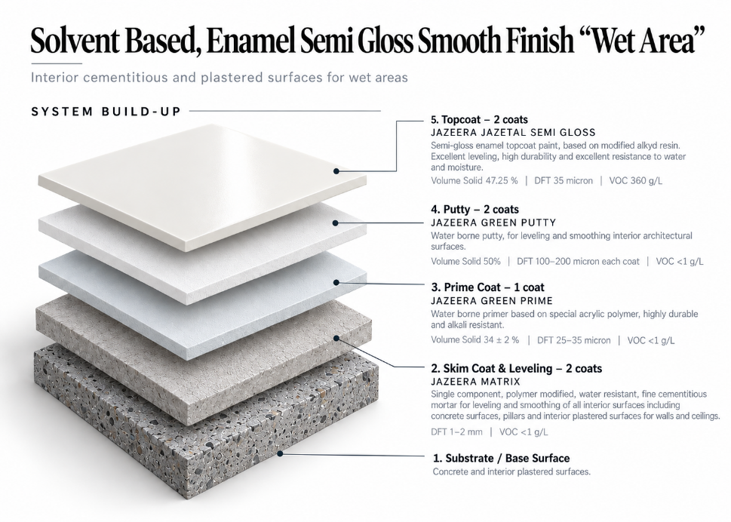

INT-CR-02 — INTERIOR SPECIAL EFFECT FINISH
PROJECT FIELD | SELECTION
Project | [INSERT PROJECT REQUIREMENT]
Area of use | [SELECT ONE: Dry-area wall / Wet-area wall / Dry-area ceiling / Wet-area ceiling / High-cleaning area / Special-performance area]
Substrate | [SELECT ONE: Concrete / Plaster / Gypsum Board / Reinforced Decorative Gypsum / Masonry]
Finish | [SELECT ONE: Special Effect / Decorative Finish]
Color | [INSERT PROJECT REQUIREMENT]
Sheen / texture | [SELECT ONE]
Performance | [EDIT TO SUIT PROJECT]

d - Water based, Special Effect Finish: “Dry Area”

1/ Jazeera Cantara
1) Skim coat and leveling: 2 coats of JAZEERA MATRIX ; single component, polymer modified, water resistant, fine cementitious mortar for leveling and smoothing of all interior surfaces including concrete surfaces, pillars and interior plastered surfaces for walls and ceilings . / DFT 1-2 mm / VOC <1 g/L
2) Prime Coat: 1 coat of JAZEERA GREEN PRIME ; water borne primer based on special acrylic polymer, highly durable and alkali resistant.
Volume Solid 34 ± 2 % / DFT 25-35 micron / VOC <1 g/L
3) Putty: 2 coats of JAZEERA GREEN PUTTY : Water borne putty, for leveling and smoothing interior architectural surfaces.
Volume Solid 50% / DFT 100-200 micron each coat / VOC <1 g/L
4) Intermediate coat: 1 coat of JAZEERA TEX PRIMER WB: Matt water-based primer, based on a special acrylic copolymer emulsion, excellent adhesion with substrate and subsequent coats.
Volume Solid 34 % / DFT 30-50 micron / VOC 34.5g/L
5) Topcoat: 2 coats of JAZEERA CANTARA: Matt topcoat paint based on acrylic copolymer emulsion, It is specially designed to give a design inspired by nature, to create an enchanting ambiance in the place.
Volume Solid 56 % / DFT 400-500 micron / VOC 23.13g/L.

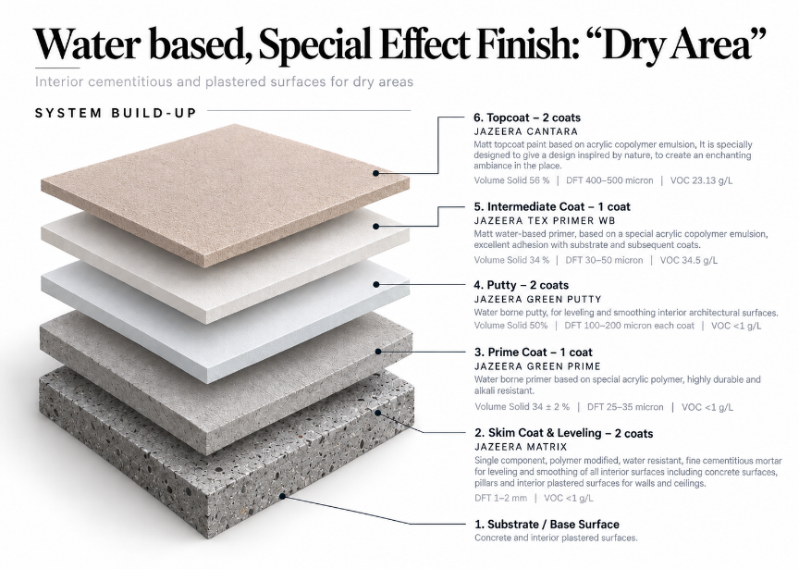

2/ Special effect with Deco Primers
System # 1
1) Skim coat and leveling: 2 coats of JAZEERA MATRIX ; single component, polymer modified, water resistant, fine cementitious mortar for leveling and smoothing of all interior surfaces including concrete surfaces, pillars and interior plastered surfaces for walls and ceilings . / DFT 1-2 mm / VOC <1 g/L
2) Prime Coat: 1 coat of JAZEERA GREEN PRIME ; water borne primer based on special acrylic polymer, highly durable and alkali resistant.
Volume Solid 34 ± 2 % / DFT 25-35 micron / VOC <1 g/L
3) Putty: 2 coats of JAZEERA GREEN PUTTY : Water borne putty, for leveling and smoothing interior architectural surfaces.
Volume Solid 50% / DFT 100-200 micron each coat / VOC <1 g/L
4) Intermediate coat: 2 Coats
A- JAZEERA DECO PRIMER: Matt water-borne basecoat paint for “Jazeera Decorative Paints”
Volume Solid 40 % / DFT 40 micron / VOC 48.10 g/L
5) Topcoat: 2 coats
a - JAZEERA TOURMALINE: water-borne decorative topcoat paint, based on a unique emulsion with smart combination of fillers and fine aggregates to provide elegant, modern stone and marble designs.
Volume Solid 50 % / DFT 250 micron / VOC 52 g/L

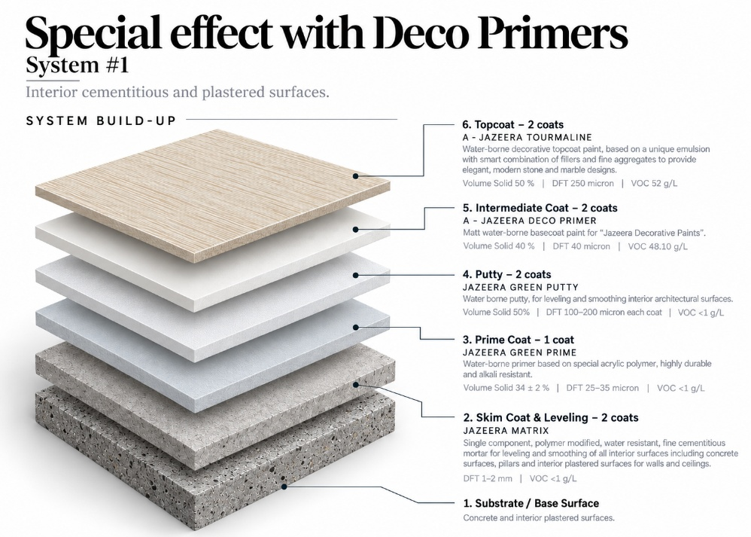

Special effect with Deco Primers
System # 2
1) Skim coat and leveling: 2 coats of JAZEERA MATRIX ; single component, polymer modified, water resistant, fine cementitious mortar for leveling and smoothing of all interior surfaces including concrete surfaces, pillars and interior plastered surfaces for walls and ceilings . / DFT 1-2 mm / VOC <1 g/L
2) Prime Coat: 1 coat of JAZEERA GREEN PRIME ; water borne primer based on special acrylic polymer, highly durable and alkali resistant.
Volume Solid 34 ± 2 % / DFT 25-35 micron / VOC <1 g/L
3) Putty: 2 coats of JAZEERA GREEN PUTTY : Water borne putty, for leveling and smoothing interior architectural surfaces.
Volume Solid 50% / DFT 100-200 micron each coat / VOC <1 g/L
4) Intermediate coat: 2 Coats
A- JAZEERA DECO PRIMER: Matt water-borne basecoat paint for “Jazeera Decorative Paints”
Volume Solid 40 % / DFT 40 micron / VOC 48.10 g/L
5) Topcoat: 2 coats
a - b - JAZEERA WOROOD: water-borne decorative topcoat paint, based on acrylic emulsion and tailor-made special effect pigment to give different metallic colors and effects from different angles of observation
Volume Solid 35 % / DFT 50 micron / VOC 14.78 g/L

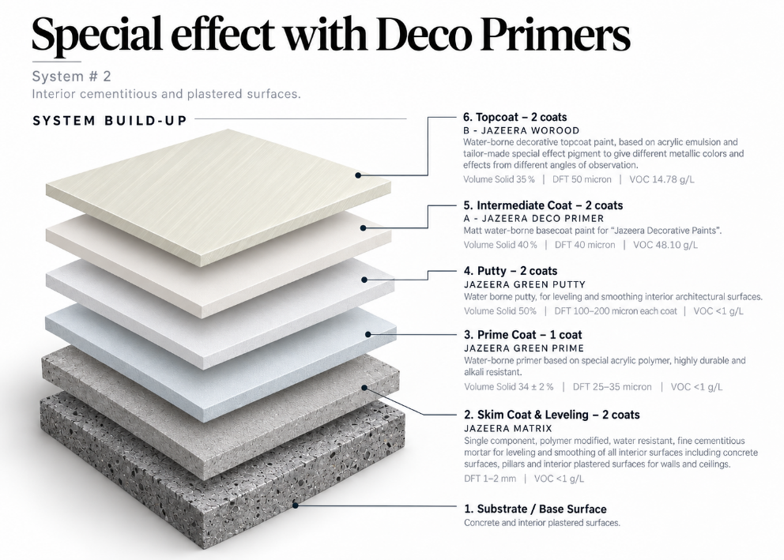

System # 3

1) Skim coat and leveling: 2 coats of JAZEERA MATRIX ; single component, polymer modified, water resistant, fine cementitious mortar for leveling and smoothing of all interior surfaces including concrete surfaces, pillars and interior plastered surfaces for walls and ceilings . / DFT 1-2 mm / VOC <1 g/L
2) Prime Coat: 1 coat of JAZEERA GREEN PRIME ; water borne primer based on special acrylic polymer, highly durable and alkali resistant.
Volume Solid 34 ± 2 % / DFT 25-35 micron / VOC <1 g/L
3) Putty: 2 coats of JAZEERA GREEN PUTTY : Water borne putty, for leveling and smoothing interior architectural surfaces.
Volume Solid 50% / DFT 100-200 micron each coat / VOC <1 g/L

4) Intermediate coat: 2 Coats
B- JAZEERA MATT DECO PRIMER: Matt water-borne basecoat paint for “Jazeera Decorative Paints”
Volume Solid 40 % / DFT 40 micron / VOC 48.10 g/L
5) Topcoat: 2 coats
A - JAZEERA ELORA: water-borne decorative topcoat paint, specially designed to decorate the walls with a coral look
Volume Solid 30 % / DFT 40-60 micron / VOC 0.5 g/L

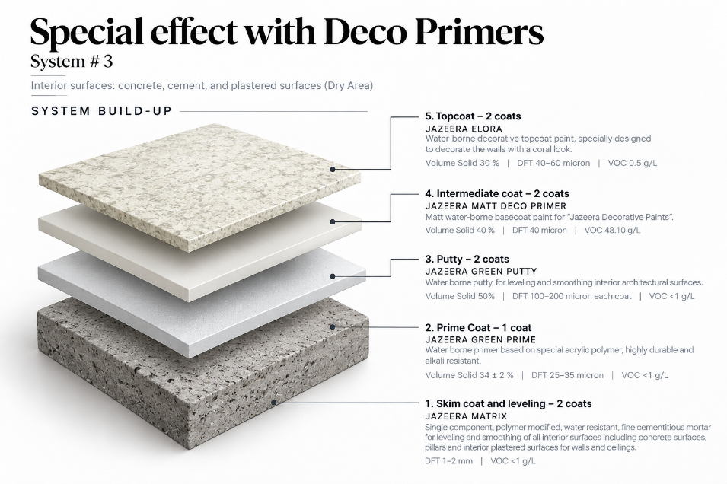

INT-CR-03 — PRODUCT-SPECIFIC SYSTEM TEMPLATE
Use this controlled template only after selecting one complete product row/system from the retained Technical Evidence Register and obtaining confirmation where required.

CLAUSE FIELD | COPY / EDIT INSTRUCTION
System code | [INSERT CONFIRMED SYSTEM CODE]
Area / substrate | [EDIT TO SUIT PROJECT] using only supported substrates
Primer | Copy exact confirmed primer name, coat count and data
Intermediate coat | Copy exact confirmed intermediate coat/putty, coat count and data; [DELETE IF NOT REQUIRED]
Topcoat | Copy exact confirmed product name, coat count and data
Thickness | Copy exact confirmed DFT/build from current TDS
Coverage | Copy exact confirmed spreading rate/coverage from current TDS
Application | Copy exact method and conditions from current TDS
Performance | Retain only substantiated tests/claims required by the project
Close-out | Append the retained Part 3 inspection, preparation, application, cleaning and protection clauses

SUSTAINABILITY AND SPECIAL-FINISH SUPPORT
Jazeera Paints products and supporting documentation achieving LEED Requirements - Ver_4, compliance pathway, project scope, and availability of current supporting documentation.
Jazeera Paints also offers a range of specialist decorative and special-effect finishes, including clay-inspired, stone-look, ornamental, and textured finishes. Contact Jazeera Paints specialists to obtain the current product range, samples, technical information, and approved system recommendations before specifying these finishes.
FINAL PUBLICATION CHECK
☐ All Priority 0 / technical-confirmation items are closed and recorded.
☐ One complete system is selected for each use/location; unused alternatives are deleted.
☐ Current TDS references, product codes, dates, coat counts, thicknesses, coverage and application data are verified.
☐ Part 1 / Part 2 / Part 3 references are consistent.
☐ Document number, revision, status, approvals, Word output and PDF output are controlled.
☐ Arabic and English versions, if published, are technically equivalent and use identical system/product/value references.
☐ Technical Services, QA/Document Control, Sustainability/Legal (as applicable), Arabic Technical Review and final approver have signed off.

AUTHORITATIVE SOURCE CONTENT — PRESERVED
The original CSI Part 1 – General, Part 2 – Products, Technical Evidence Register, and Part 3 – Execution sections are provided below. Technical text and product evidence have been retained from the attached source file.
The preceding guide shall be used as the navigation, selection, and editing framework. Any editorial changes shall not alter the verified technical intent or product requirements.
Publication shall not proceed until all applicable items in the Technical Confirmation Register have been technically reviewed, supporting evidence has been verified, and the register has been formally closed.

2. Extracted Technical Evidence from Attached TDS

Ref. | Attached filename |  | Type | Product / code | Document / date | Supported evidence | Substrate | Control decision | DFT | VS | Spreading rate | Build | VOC | Recoat / cure
FILLERS
S01 | JAZEERA CRACK FILLER |  | Two-components filler for filling cracks and pores of concrete and cement surfaces, based on acrylic emulsion | JA-12001 | Issued 2026 | For exterior and interior applications for filling small cracks up to 1 cm and holes of. | Concrete, cement and brick surfaces | Surface-repair accessory,  Painting System:  • Apply “Jazeera Crack Filler” until the cracks are filled completely and the surface becomes levelled | Filling Range Up to 1 cm | 50 % | Depends on application | 1coat | NA | • Surface dry  2 hrs.  • Recoating interval 8 hrs (minimum).  • Full cure 24 hrs.
S02 | JAZEERA ULTIMATE |  | Light weight filler, easy to apply based on an innovative emulsion | JA-12005 | Issued 2026 | For exterior and interior applications to repair small holes and cracks | Concrete, plaster, gypsum, and bricks surfaces | Suitable accessory candidate; TDS states it is not a levelling putty or joint filler.  Painting System:  • Apply one coat of “Jazeera Ultimate” to fill the cracks and small holes  • Paintable for all type of paints (water base or solvent based) | Filling Range up to 2 cm wide and 2 cm depth. | 70 % | Depends on application | 1coat | NA | • Surface dry (3-4) hrs.  • Full dry 24 hrs.  • Recoating interval (48-72) hrs.
S03 | JAZEERA EPOXY CRACK FILLER 400 |  | A high quality two-component repair putty, solvent free, based on epoxy polyamide cured which has been modified to fill the hollow spaces  and cracks. | JI-62015 | Issued 2026 | Filler to fill up cracks, pores and hollows, as well as for repairs purposes, in exterior and interior applications. | Concrete, cement, gypsum, wood and steel surfaces | Project-specific repair accessory; confirm topcoat compatibility.  Painting System:  Fill pores, hollows and cracks with “Jazeera Epoxy Crack Filler 400” until the surface becomes leveled and smooth. | Filling Range 0.5–2 cm | 100 % | Depends on application | 1coat | 9.15 g/L | • Surface dry 5hrs.  • Recoating Interval 7 hours (minimum)  • Full cure  7 days.
S04 | JAZEERA UNIQUE FILLER |  | Light weight, two components, solvent free epoxy filler for horizontal and vertical joints | JI-62008 | Issued 2026 | For exterior and interior applications for vertical and horizontal cracks and joints | Concrete and cement substrates,  such as columns, walls, ceilings of buildings and facilities etc. | Special repair accessory; not a substitute for Green Putty.  Painting System:  • Apply “Jazeera Unique Filler” to fill large cracks or joints  • Apply any of epoxy or solvent based or water based topcoats | Filling Range up to 4 cm width and 8 cm depth | 100 % | Depends on application | 1coat | <1 g/L | • Surface dry 2hrs.  •Hard dry 4-6 hrs.  •Recovering overcoating interval 24 hrs.
S05 | JAZEERA UNIQUE JOINT |  | Two component epoxy based light weight filler, specially formulated to seal joints between cement boards and concrete panels | JI-62012 | Issued 2026 | For exterior and interior applications for filling joints between cement boards and concrete panels.  Also for sealing  surface cracks, pores and patching the boards’ fastening screws. | Cement boards, concrete panels | Joint-treatment  Application Method  •Over joints application:  -Install self-sticking fiberglass tape on the joint.  -Apply Jazeera Unique Joint by putty blade or any suitable tool_  •For sealing surface cracks & pores:  -Apply Jazeera Unique Joint by putty knife or any suitable tool after mixing directly:  •For Exterior Applications:  -The topcoats paints should be applied after 7 days of application.  -Start sanding after 24 hours of application | Filling Range 0.5–2 mm | 100 % | Depends on application | 1coat | <1 g/L | • Surface dry 2hrs.  • Hard dry  2-4 hrs.  • To achieve mechanical & chemical resistance:  7 days
 |  | SKIM COAT
S01 | JAZEERA MATRIX |  | single component, polymer modified, fine cementitious mortar | JK-13001 | Issued 2026 | Used for leveling and smoothing of all interior surfaces including concrete surfaces, pillars and interior plastered surfaces for walls and  Ceilings.  -VOC Emission After application Pass LEED Req. Ver_4 | concrete, plastered surfaces | Recommended System:  • Apply two coats of “ Jazeera Matrix ”_  • Apply any interior painting system_ | 1-2 mm | 100% | 0_5 – 1_0 kg/m²/mm | 2coats | <0.1 g/L. | cured with soft water spray after 12 hours from application for the first two days.
PRIMERS
S01 | JAZEERA GREEN PRIME |  | Water borne primer based on special acrylic polymer | JA-11020 | Issued 2026 | Interior applications. provides a good adhesion and high durability and alkali resistance.  -Meets MPI Standard # 50  -VOC Emission After Application: Pass LEED Requirements Ver_4  -SASO standard 2060/2018 | Concrete, cement, gypsum and brick | Best-supported candidate interior primer,  Painting System:  Apply one coat of "Jazeera Green Prime"  Apply any interior water based painting system from Jazeera Paints | 25-35 µ. | 34 ± 2 % | 9.7 - 13.6 m²/L | 1coat | <0.1 g/L. | • Surface dry 30 minutes.  • Hard dry 2 hrs.  • Recoating interval 8 hours. (minimum)
S02 | JAZEERA INTERIOR PRIMER |  | Water borne primer based on acrylic copolymer emulsion | JA-11029 | Issued 2026 | Interior applications. provides a good adhesion and high durability and alkali resistance.  -Meets MPI Standard # 50  -VOC Emission After Application: Pass LEED Requirements Ver_4  -SASO standard 2060/2018 | Concrete, cement, gypsum and brick | Best-supported candidate interior primer,  Painting System:  Apply one coat of "Jazeera Green Prime"  Apply any interior water based painting system from Jazeera Paints | 30 µ. | 29 % | 9.6 m²/L | 1coat | <0.1 g/L. | • Surface dry 30 minutes.  • Hard dry 2 hrs.  • Recoating interval 8 hours. (minimum)
S05 | JAZEERA BLOCKING PRIMER.pdf |  | Solvent based primer and sealer, based on a special synthetic copolymer | JA-41005 | Issued 2026 | Interior and exterior applications. It is considered the ideal primer in case of maintenance | Concrete, cement plasters and gypsum surfaces | special/maintenance primer. | 40 µ. | 37 % | 9.25 m²/L | 1coat | 529 g/L. | • Surface dry 30 minutes.  • Hard dry 4 hrs.  • Recoating interval 4 hours. (minimum)
S06 | JAZEERA C PRIMER |  | Solvent base, clear primer, based on acrylic resin | JA-41001 | Issued 2026 | Exterior and interior application, It is specially recommended to resist alkali and moisture  Termite Resistance: Pass | Concrete, cement plasters and gypsum surfaces | Candidate special option only;  •Apply one coat of "Jazeera Blocking Primer”  •Apply any of interior or exterior architectural painting system from Jazeera Paints. | 15-25 µ. | 17 % | 6.8 - 11.3 m²/L | 1coat | NA | • Surface dry 30 minutes.  • Hard dry 1 hr.  • Recoating interval 2 hrs. (minimum)
S07 | JAZEERA MAX PRIMER |  | Water borne primer based on special acrylic polymer | JA-11031 | Issued 2026 | Exterior and interior application, It is recommended for double hiding. | Concrete, cement plasters and gypsum surfaces | •Apply one coat of "Jazeera Max Primer”  •Apply any of interior or exterior architectural painting system from Jazeera Paints. | 25 µ. | 46.48 % | 18.6 m²/L | 1coat | NA | • Surface dry 30 minutes.  • Hard dry 2 hrs.  • Recoating interval 4 hrs. (minimum)
S08 | JAZEERA SILANE PRIMER |  | Solvent borne clear primer, based on silane-siloxane and acrylic | JA-41003 | Issued 2026 | Exterior and interior application, It is specially recommended to protect the concrete structures from attack by acid gases, chloride ions and water. | concrete, cement, and brick surfaces | Special-purpose candidate only; system purpose/finish  •Apply one coat of "Jazeera C Primer”  •Apply any of interior or exterior architectural painting system from Jazeera Paints. | 10 µ. | 10 ± 2 % | 10 m²/L | 1coat | VOC 771 g/L | • Surface dry 3 hrs.  • Hard dry 6 hrs.  • Recoating interval 6 hrs. (minimum)
PUTTIES
S01 | JAZEERA GREEN PUTTY |  | A water borne putty, based on special formulation, designed for leveling and smoothing surfaces. | JA-13019 | Issued 2026 | Interior applications, Excellent porous filling  -Provide leveled & smooth surface  -Superior adhesion with substrate and subsequent coats.  -Easy to apply and sanding_  - VOC Emission After Application: Pass LEED Requirements Ver_4  -SASO 2107/2019  Meets MPI #4;  - Passed : Chemical Resistance / Salt Resistance /  Alkali Resistance | concrete, cement, wood and brick surfaces | Painting System:  • Apply one coat of "Jazeera Green Prime" or any other suitable primer from Jazeera Paints, depending on the surface nature  • Apply two coats of “Jazeera Green Putty”  • Apply any interior architectural topcoat paint from Jazeera Paints | 100-200 µ. | 50 % | 1.5-3 m²/kg | 2  coats | <1  g/L | • Surface dry 20 minutes.  • Hard dry 2 hrs.  • Recoating interval 2 hrs. (minimum)
S02 | JAZEERA PUTTY |  | water borne putty, based on acrylic copolymer, designed to provide leveled and smooth surfaces | JA-13021 | Issued 2025 | Interior applications, Excellent porous filling  -Provide leveled & smooth surface  -Superior adhesion with substrate and subsequent coats. | concrete, cement and brick surfaces | Painting System:  • Apply one coat of "Jazeera Interior Prime" or any other suitable primer from Jazeera Paints, depending on the surface nature  • Apply two coats of “Jazeera Putty”  • Apply any interior architectural topcoat paint from Jazeera Paints | 100-200 µ. | 50 ±2 % | 1.5-3 m²/kg | 2  coats | <1  g/L | • Surface dry 30 minutes.  • Hard dry 2 hrs.  • Recoating interval 2 hrs. (minimum)
S03 | JAZEERA GYPSONEAT |  | water borne putty based on special type of emulsion and modifiers, specially used for leveling and smoothing both vertical and  horizontal gypsum surfaces | JA-13004 | Issued 2026 | Interior applications for filling holes and cracks, and leveling gypsum surfaces  -VOC Emission After application Pass LEED Req. Ver_4  -SASO 2107/2019 | Gypsum surfaces | Painting System:  • Apply one coat of "Jazeera C Primer" or any other suitable primer from Jazeera Paints.  • Apply two coats of “Jazeera Gypsoneat” over primer as above mentioned.  • Apply any interior architectural topcoat paint from Jazeera Paints | 150–200 µ | 52 % | 1.5-1.98 m²/kg | 2  coats | NA | • Surface dry 20 minutes.  • Hard dry 2 hrs.  • Recoating interval 2 hrs. (minimum)
INTERMEDIATE COATS
S05 | JAZETAL UNDER COAT |  | Undercoat paint based on modified alkyd resin | JA-31001 | Issued 2026 | Interior and exterior applications on various substrates,  in industrial workshops, commercial areas and residential buildings. | Wood, fiber glass boards, and sealed masonry surfaces | Painting System:  For concrete surfaces:  • Apply one coat of "Jazeera Green Prime"  • Apply two coats of “Jazeera Green Putty”  • Apply one coat of “Jazetal Under Coat”  • Apply any suitable architectural paint from Jazeera Paints.  For wooden surfaces:  • Apply one coat of “Jazetal Under Coat”  • Apply any suitable wood paint from Jazeera Paints | 40 µ | 54 % | 13.5 m²/L | 1coat | 364 g/L | • Surface dry 2 hrs  • Hard dry 16 hrs  • Recoating interval 16 hrs (minimum)
PLAIN EMULSION INTERIOR TOPCOATS
S01 | JAZEERA GREEN MATT |  | Matt emulsion topcoat paint, based on pure acrylic polymer | JA-15029 | Issued 2026 | Provide exceptional hiding and leveling properties, For ceilings, bedrooms or where matt finish is required in palaces, hotels, airports, hospitals, schools, houses  -VOC Emission After application Pass LEED Req. Ver_4  - SASO 2582_2022  Meets MPI #53;  -Washability pass ASTM D4828  - Impact Resistance No cracks were observed ASTM D2794 | concrete, cement, gypsum and brick surfaces | • Apply one coat of "Jazeera Green Prime" or any other suitable primer from Jazeera Paints, depending on the surface nature.  • Apply two coats of “Jazeera Green Putty”.  • Apply two coats of “Jazeera Green Matt”. | 35-60 µ | 40 ± 2 % | 6.67-11.43 m²/L | 2  coats | <1 g/L | Surface dry 30 minutes  Hard dry 4 hours  Recoating interval  8 hrs (minimum)
S02 | JAZEERA GREEN SILK |  | Silk emulsion topcoat paint, based on pure acrylic polymer | JA-16048 | Issued 2026 | Provide exceptional hiding and leveling properties, For houses corridors, restaurants, halls, gym, lobby and offices.  VOC Emission After Application: Pass LEED Req. Ver_4  - SASO 2582-2022  Meets MPI #52;  -Washability pass ASTM D4828  - Impact Resistance No cracks were observed ASTM D2794 | concrete, cement, gypsum and brick surfaces | • Apply one coat of "Jazeera Green Prime" or any other suitable primer from Jazeera Paints, depending on the surface nature.  • Apply two coats of “Jazeera Green Putty”.  • Apply two coats of “Jazeera Green Silk”. | 30-50 µ | 40 ± 2 % | 8-13.33 m²/L | 2  coats | <1 g/L | Surface dry 30 minutes  Hard dry 4 hours  Recoating interval  8 hrs (minimum)
S03 | JAZEERA GREEN SEMIGLOSS |  | Semi-gloss emulsion topcoat paint, based on pure acrylic polymer | JA-17010 | Issued 2026 | Provide exceptional hiding and leveling properties, For palaces, hotels, airports, hospitals,  schools, houses.  -VOC Emission After application Pass LEED Req. Ver_4  - SASO 2582-2022  Meets MPI #54;  -Scrub Resistance Pass ASTM D2486  -Washability pass ASTM D4828  - Impact Resistance No cracks were observed ASTM D2794 | concrete, cement, gypsum and brick surfaces | • Apply one coat of "Jazeera Green Prime" or any other suitable primer from Jazeera Paints, depending on the surface nature.  • Apply two coats of “Jazeera Green Putty”.  • Apply two coats of “Jazeera Green Semigloss”. | 35-75 µ | 38 ± 2 % | 5.1 – 10.86 m²/L | 2  coats | <1 g/L | Surface dry 30 minutes  Hard dry 4 hours  Recoating interval  8 hrs (minimum)
S04 | JAZEERA GREEN GLOSS |  | Gloss emulsion topcoat paint, based on pure acrylic polymer | JA-18011 | Issued 2026 | Provide exceptional hiding and leveling properties, For palaces, hotels, airports, hospitals,  schools, houses.  -VOC Emission After application Pass LEED Req. Ver_4  - SASO 2582-2022  -Washability pass ASTM D4828  - Impact Resistance No cracks were observed ASTM D2794 | concrete, cement, gypsum and brick surfaces | • Apply one coat of "Jazeera Green Prime" or any other suitable primer from Jazeera Paints, depending on the surface nature.  • Apply two coats of “Jazeera Green Putty”.  • Apply two coats of “Jazeera Green Gloss”. | 35-75 µ | 40 ± 2 % | 5.1 – 10.86 m²/L | 2  coats | <1 g/L | Surface dry 30 minutes  Hard dry 4 hours  Recoating interval  8 hrs (minimum)
S05 | JAZEERA GLORY MATT |  | Matt emulsion topcoat paint, based on special acrylic polymer | JA-15059 | Issued 2026 | Provide exceptional hiding and leveling properties, For ceilings, bedrooms or where matt  finish is required in palaces, hotels, airports, hospitals, schools, houses  -VOC Emission After application Pass LEED Req. Ver_4  -Wet Scrub Resistance Pass 10000 cycles DIN 53778-2_1983  -Washability pass ASTM D4828  - Impact Resistance No cracks were observed ASTM D2794 | concrete, cement, gypsum and brick surfaces | • Apply one coat of "Jazeera Green Prime" or any other suitable primer from Jazeera Paints, depending on the surface nature.  • Apply two coats of “Jazeera Green Putty”.  • Apply two coats of “Jazeera Glory Matt”. | 40 µ | 36 ± 2 % | 9 m²/L | 2  coats | 7.6 g/L | Surface dry 30 minutes  Hard dry 4 hours  Recoating interval  8 hrs (minimum)
S06 | JAZEERA GLORY SILK |  | Silk emulsion topcoat paint, based on special acrylic polymer | JA-16073 | Issued 2026 | Provide exceptional hiding and leveling properties, For houses corridors, restaurants, halls, gym, lobby and offices.  Pass LEED Req. Ver_4  -Washability pass ASTM D4828  - Impact Resistance No cracks were observed ASTM D2794 | concrete, cement, gypsum and brick surfaces | • Apply one coat of "Jazeera Green Prime" or any other suitable primer from Jazeera Paints, depending on the surface nature.  • Apply two coats of “Jazeera Green Putty”.  • Apply two coats of “Jazeera Glory Silk”. | 40 µ | 33 ± 2 % | 8.25 m²/L | 2  coats | 7.9 g/L | Surface dry 30 minutes  Hard dry 4 hours  Recoating interval  8 hrs (minimum)
S07 | JAZEERA GLORY SEMIGLOSS |  | Semi-gloss emulsion topcoat paint, based on special acrylic polymer. | JA-17023 | Issued 2026 | Provide exceptional hiding and leveling properties, For palaces, hotels, airports, hospitals,  schools, houses.  -VOC Emission After application Pass LEED Req. Ver_4  -Washability pass ASTM D4828  - Impact Resistance No cracks were observed ASTM D2794 | concrete, cement, gypsum and brick surfaces | • Apply one coat of "Jazeera Green Prime" or any other suitable primer from Jazeera Paints, depending on the surface nature.  • Apply two coats of “Jazeera Green Putty”.  • Apply two coats of “Jazeera Glory Semigloss”. | 40 µ | 32 ± 2 % | 8m²/L | 2  coats | 7.8 g/L | Surface dry 30 minutes  Hard dry 4 hours  Recoating interval  8 hrs (minimum)
S08 | JAZEERA INTERIOR EMULSION |  | Matt emulsion topcoat paint, based on acrylic copolymer emulsion. | JA-15046 | Issued 2025 | Provide exceptional hiding and leveling properties, For ceilings, bedrooms or where matt  finish is required in palaces, hotels, airports, hospitals, schools, houses | concrete, cement, gypsum and brick surfaces | • Apply one coat of "Jazeera Interior Primer" or any other suitable type of Jazeera primers, depending on the surface nature.  • Apply two coats of “Jazeera Putty”  • Apply two coats of “Jazeera Interior Emulsion”. | 30 µ | 35 % | 11.66 m²/L | 2  coats | <1 g/L | Surface dry 30 minutes  Hard dry 4 hours  Recoating interval  8 hrs (minimum)
S09 | JAZEERA INTERIOR EMULSION SILK |  | Silk emulsion topcoat paint, based on acrylic copolymer emulsion. | JA-16067 | Issued 2025 | Provide exceptional hiding and leveling properties, For houses corridors, restaurants, halls, gym, lobby and offices. | concrete, cement, gypsum and brick surfaces | • Apply one coat of "Jazeera Interior Primer" or any other suitable type of Jazeera primers, depending on the surface nature.  • Apply two coats of “Jazeera Putty”  • Apply two coats of “Jazeera Interior Emulsion”. | 35 µ | 38% | 11 m²/L | 2  coats | 19.75 g/L | Surface dry 30 minutes  Hard dry 4 hours  Recoating interval  8 hrs (minimum)
ANTIMICROBIC EMULSION INTERIOR TOPCOATS
S01 | JAZEERA GREEN ANTIMICROBIC |  | Silk emulsion topcoat paint, based on 100% pure acrylic polymer emulsion | JA-16058 | Issued 2026 | For hospitals, operation theatres, clinics, children rooms, bedrooms, dining halls, microbiological laboratories, etc. Pass LEED Req. Ver_4  It is specially recommended for those where resistance to  microbes and fungi is required.  -Wet Scrub Resistance Pass 20000 cycles ISO 11998 / DIN 53778 -Flame Spread Resistance Class1ASTM E84  -Fungal resistance Pass BS 3900_Part G6  -Antimicrobial activity Pass JIS Z 2801_2010  -Washability Pass ASTM D4828  -Scrub-ability Pass 450 Cycles ASTM D2486 | concrete, cement, gypsum and brick surfaces | • Apply one coat of "Jazeera Green Prime" or any other suitable primer from Jazeera Paints, depending on the surface nature.  • Apply two coats of “Jazeera Green Putty”.  • Apply two coats of “Jazeera Green Antimicrobic”. | 30-50 µ | 35 ± 2 % | 7-11.6 m²/L | 2  coats | 5.4 g/L | Surface dry 30 minutes  Hard dry 4 hours  Recoating interval  8 hrs (minimum)
S02 | JAZEERA GREEN ANTIMICROBIC MATT |  | Matt emulsion topcoat paint, based on 100% pure acrylic polymer emulsion | JA-15043 | Issued 2026 | For hospitals, operation theatres, clinics, children rooms, bedrooms, dining halls, microbiological laboratories, etc.  -VOC Emission After application Pass LEED Req. Ver_4  It is specially recommended for those where resistance to  microbes and fungi is required.  -Wet Scrub Resistance Pass 20000 cycles ISO 11998 / DIN 53778 -Flame Spread Resistance Class1ASTM E84  -Fungal resistance Pass BS 3900_Part G6  -Antimicrobial activity Pass JIS Z 2801_2010  -Washability Pass ASTM D4828  -Scrub-ability Pass 450 Cycles ASTM D2486  -Wet adhesion Pass / class1 BS 7719-1994 CI 8.8  -Mud Cracking Pass @ WET 1250 micron BS 7719-1994 CI 8.5 | concrete, cement, gypsum and brick surfaces | • Apply one coat of "Jazeera Green Prime" or any other suitable primer from Jazeera Paints, depending on the surface nature.  • Apply two coats of “Jazeera Green Putty”.  • Apply two coats of “Jazeera Green Antimicrobic Matt”. | 30-50 µ | 35 ± 2 % | 7-11.6 m²/L | 2  coats | <1 g/L | Surface dry 30 minutes  Hard dry 4 hours  Recoating interval  8 hrs (minimum)
S03 | JAZEERA GLORY ANTIMICROBIC MATT |  | Matt emulsion topcoat paint, based on special acrylic polymer | JA-15076 | Issued 2026 | For hospitals, operation theatres, clinics, children rooms, bedrooms, dining halls, microbiological laboratories, etc.  It is specially recommended for those where resistance to  microbes and fungi is required.  -Antibacterial activity and efficacy Pass JIS Z 2801_2010(SIAA/JSA) | concrete, cement, gypsum and brick surfaces | • Apply one coat of "Jazeera Green Prime" or any other suitable primer from Jazeera Paints, depending on the surface nature.  • Apply two coats of “Jazeera Green Putty”.  • Apply two coats of “Jazeera Glory Antimicrobic Matt”. | 40 µ | 36 ± 2 % | 9 m²/L | 2  coats | NA | Surface dry 30 minutes  Hard dry 4 hours  Recoating interval  8 hrs (minimum)
S04 | JAZEERA GLORY ANTIMICROBIC SILK |  | Silk emulsion topcoat paint, based on special acrylic polymer | JA-16082 | Issued 2026 | For hospitals, operation theatres, clinics, children rooms, bedrooms, dining halls, microbiological laboratories, etc.  It is specially recommended for those where resistance to  microbes and fungi is required.  -Antibacterial activity and efficacy Pass JIS Z 2801_2010(SIAA/JSA) | concrete, cement, gypsum and brick surfaces | • Apply one coat of "Jazeera Green Prime" or any other suitable primer from Jazeera Paints, depending on the surface nature.  • Apply two coats of “Jazeera Green Putty”.  • Apply two coats of “Jazeera Glory Antimicrobic Silk”. | 40 µ | 33 ± 2 % | 8.25 m²/L | 2  coats | NA | Surface dry 30 minutes  Hard dry 4 hours  Recoating interval  8 hrs (minimum)
S05 | JAZEERA GLORY ANTIMICROBIC SG |  | Semi-gloss emulsion topcoat paint, based on special acrylic polymer | JA-17025 | Issued 2026 | For hospitals, operation theatres, clinics, children rooms, bedrooms, dining halls, microbiological laboratories, etc.  It is specially recommended for those where resistance to  microbes and fungi is required.  -Antibacterial activity and efficacy Pass JIS Z 2801_2010(SIAA/JSA) | concrete, cement, gypsum and brick surfaces | • Apply one coat of "Jazeera Green Prime" or any other suitable primer from Jazeera Paints, depending on the surface nature.  • Apply two coats of “Jazeera Green Putty”.  • Apply two coats of “Jazeera Glory Antimicrobic SG”. | 40 µ | 32 ± 2 % | 8 m²/L | 2  coats | NA | Surface dry 30 minutes  Hard dry 4 hours  Recoating interval  8 hrs (minimum)
HIGH PERFORMANCE INTERIOR TOPCOATS
S01 | JAZEERA NOVEL |  | A 100% pure acrylic water based paint with smooth silk effect, based on unique self-cross-linking technology | JA- 16024 | Issued 2026 | luxurious and high end areas such as palaces, hotels, houses, hospitals, halls, residential complexes and all crowded interior areas where high stain resistance  and hygienic properties are required.  •VOC Emission After Application Pass LEED Req - Ver_4  • Scrub Test Pass 7000 scrubs ASTM D2486.  • Anti-bacterial Pass JIS Z 2801_2010  • Fungal Resistance Pass BS 3900_ PART G6  • Flame Spread Resistance Class 1 BS 476_ Part 7  • Chemical resistance Pass 7day / class A ASTM D1308-02(2013)  • Crack bridging Pass crack width 1.5mm EN 1062-7_2004  • Wet Scrub Resistance Loss in coating mass 1.61 g/m² / 200 cycles ISO 11998 / Pass 25000 cycles DIN 53778 | concrete, cement, gypsum and brick surfaces | • Apply one coat of "Jazeera Green Prime" or any other suitable primer from Jazeera Paints, depending on the surface nature.  • Apply two coats of “Jazeera Green Putty”.  • Apply two coats of “Jazeera Novel”. | 30-50 µ | 40.4 % | 8-13.5m²/L | 2  coats | 0 | Surface dry 30 minutes  Hard dry 4 hours  Recoating interval  8 hrs (minimum)
S02 | JAZEERA NOVEL CHARM |  | A water borne paint, with ideal gloss level, based on 100% pure acrylic, based on unique self-cross-linking technology | JA- 15045 | Issued 2026 | luxurious and high end areas such as palaces, hotels, houses, hospitals, halls, residential complexes and all crowded interior areas where high stain resistance and hygienic properties are required.  • Wet Scrub Resistance Pass 15000 cycles ISO 11998 / DIN 53778  • Fungal Resistance Pass BS 3900 PART G6  • Flame Spread Resistance Class 1 BS 476_ Part 7  -VOC Emission After application Pass LEED Req. Ver_4  • Crack bridging Pass crack width 1.78mm EN 1062-7  • Wet Scrub Resistance Pass 15000 cycles ISO 11998 / DIN 53778 | concrete, cement, gypsum and brick surfaces | • Apply one coat of "Jazeera Green Prime" or any other suitable primer from Jazeera Paints, depending on the surface nature.  • Apply two coats of “Jazeera Green Putty”.  • Apply two coats of “Jazeera Novel Charm”. | 30-50 µ | 42 ±2 % | 8.4 – 14 m²/L | 2  coats | 2.6 g/L | Surface dry 30 minutes  Hard dry 4 hours  Recoating interval  8 hrs (minimum)
S03 | JAZEERA NOVEL SEMI GLOSS |  | A 100% pure acrylic water based paint smooth semi-gloss finish, based on unique self-cross-linking technology | JA- 17022 | Issued 2026 | luxurious and high end areas such as palaces, hotels, houses, hospitals, halls, residential complexes and all crowded interior areas where high stain resistance.  and hygienic properties are required.  • Optimum continuous washability.  • Excellent resistance to microbes (bacteria & fungi).  • Excellent scrub resistance.  • Long-lasting color and gloss retention. | concrete, cement, gypsum and brick surfaces | • Apply one coat of "Jazeera Green Prime" or any other suitable primer from Jazeera Paints, depending on the surface nature.  • Apply two coats of “Jazeera Green Putty”.  • Apply two coats of “Jazeera Novel Semi Gloss”. | 30-40 µ | 38 % | 9.5 – 12.67 m²/L | 2  coats | NA | Surface dry 30 minutes  Hard dry 4 hours  Recoating interval  8 hrs (minimum)
ANTICARBONATION INTERIOR TOPCOATS
S01 | JAZEERA ROYAL GRAND CARBO |  | water borne eggshell topcoat paint, based on acrylic emulsion and specialized high performing binder | JA-15060 | Issued 2026 | It has anti-carbonation properties and water resistance, water vapor permeability features, which guarantees the  protection and durability for surfaces, used as a protective and decorative topcoat for interior applications for car parks.  •VOC Emission After Application Pass LEED Req - Ver_4  •Crack bridging pass crack 0.86mm width EN 1062-7• Tensile strength 3.79 N/mm2 ASTM D412-16  • Elongation 24.5 % ASTM D412-16  • Carbon Dioxide Permeability Test (BS EN 1062-6_2002 Method A)  • Water - Vapor Transmission Rate (Permeability ) / DIN EN ISO 7783 | concrete, cement and other masonry substrates | Painting System:  • Apply one coat of "Jazeera Green Prime" or any other suitable type of Jazeera primers, depending on the surface nature.  • Apply two coats or more of "Jazeera Royal Grand Carbo" | 30-50 µ | 36 ±2% | 7.2 – 12  m²/L | 2 coats | 16.18 g/L | Surface dry 30 minutes  Hard dry 4 hours  Recoating interval  8 hrs (minimum)
S02 | JAZEERA ROYAL GRAND CARBO MATT |  | water borne matt topcoat paint, based on acrylic emulsion and specialized high performing binder | JA- 15061 | Issued 2026 | It has anti-carbonation properties and water resistance, water vapor permeability features, which guarantees the  protection and durability for surfaces, used as a protective and decorative topcoat for interior applications for car parks.  •VOC Emission After Application Pass LEED Req - Ver_4  •Crack bridging pass crack 0.32mm width EN 1062-7  • Tensile strength 5.56 N/mm2 ASTM D412-16  • Elongation 24.5 % ASTM D412-16  • Carbon Dioxide Permeability Test (BS EN 1062-6_2002 Method A)  • Water - Vapor Transmission Rate (Permeability ) / DIN EN ISO 7783 | concrete, cement and other masonry substrates | Painting System:  • Apply one coat of "Jazeera Green Prime" or any other suitable type of Jazeera primers, depending on the surface nature.  • Apply two coats or more of "Jazeera Royal Grand Carbo Matt" | 30-50 µ | 37.23 % | 7.4 – 12.4  m²/L | 2 coats | 7.1 g/L | Surface dry 30 minutes  Hard dry 4 hours  Recoating interval  8 hrs (minimum)
COVER CEILING DEFECTS
S01 | JAZEERA SUPER WHITE |  | matt emulsion paint, based on acrylic copolymer binder, available in white and brilliant white | JA-15054 | Issued 2026 | Interior applications, ideal for ceilings, or where matt finish is  required in Palaces, hotels, airports, hospitals, schools, houses, etc.  It can be used as undercoat for emulsion topcoats.  Hide minor imperfections of ceilings. | concrete, cement, gypsum and brick surfaces | Painting System:  • Apply one coat of "Jazeera Green Prime" or any other suitable primer from Jazeera Paints, depending on the surface nature_  • Apply two coats of “Jazeera Green Putty” /“Jazeera Gypsoneat” depending on the surface type.  • Apply two coats of “Jazeera Super White” | 35 µ | 36 % | 10.3m²/L | 2 coats | NA | Surface dry 30 minutes  Hard dry 4 hours  Recoating interval  8 hrs (minimum)
S02 | JAZEERA GREEN SILK FLEXY |  | Highly durable flexible silk topcoat paint, based on pure acrylic emulsion | JA-16055 | Issued 2026 | Interior applications when exceptional properties to cover defects and bridge cracks are required in commercial centers, car parks,  warehouses, large halls, gyms and modern houses.  • Meets MPI Standard #155  • Cleanability Pass ASTM D3450  • Scrub Resistance Pass ASTM D2486  • Flame Spread Resistance Pass ASTM E84  • Anti-bacterial Pass JIS Z 2801_2010 AM Solutions-Poland  • Fungal Resistance Pass BS 3900_ PART G6  •VOC Emission After Application Pass LEED Req - Ver_4 | concrete, black steel, galvanized steel, aluminum, plastic, polyethylene and all types of PVC surfaces | Painting System:  • Apply two coats of “Jazeera Green Silk Flexy” directly. | 30-50 µ | 33% | 6.6-11m²/L | 2 coats | 21.97 g/L | Surface dry 30 minutes  Hard dry 4 hours  Recoating interval  8 hrs (minimum)
S03 | JAZEERA GREEN MATT FLEXY |  | Highly durable flexible matt topcoat paint, based on pure acrylic emulsion | JA-15037 | Issued 2026 | Interior applications when exceptional properties to cover defects and bridge cracks are required in commercial centers, car parks,  warehouses, large halls, gyms and modern houses.  • Flame Spread Resistance Pass class 1 ASTM E84  • Scratch resistance Pass BS EN ISO 1518_2019 | concrete, black steel, galvanized steel, aluminum, plastic, polyethylene and all types of PVC surfaces | Painting System:  • Apply two coats of “Jazeera Green Matt Flexy” directly. | 30-50 µ | 33% | 6.6-11m²/L | 2 coats | <1 g/L | Surface dry 30 minutes  Hard dry 4 hours  Recoating interval  8 hrs (minimum)
INTERIOR TEXTURE TOPCOATS
S01 | JAZEERA SOFTEX INTERIOR / EXTERIOR |  | A soft finish texture paint based on acrylic emulsion provides different pressable granular designs | JA-25079 | Issued 2026 | Interior applications for educational institutions, residential, commercial and industrial buildings.  -High resistance to different weather conditions.  -Highly durable and excellent adhesion.  -Excellent resistance to water.  -High resistance to abrasion  VOC Emission After application Pass LEED Req. Ver_4  -SASO standard GSO 2592/2022  -Meets MPI standard # 42 | concrete, cement and brick surfaces | Painting System:  • Apply one coat of Jazeera Green Prime or any other suitable primer from Jazeera Paints, depending on the surface nature.  • Apply one coat of "Jazeera Softex Interior/Exterior".  • Apply 2 coats of "Jazeera Green Matt / Silk / Semigloss / Gloss" or any suitable interior topcoats from Jazeera Paints. | 175-450 µ | 55% | 1.0-2.7 m²/Kg | 1 coat | 12.34 g/L | Surface dry 2 hrs  Hard dry 24 hours  For pressing (20 – 30) minutes
S02 | JAZEERA MASHASHCO |  | A two-component traditional decorative coat, based on acrylic polymer, provides the old clay houses design | JA-25011 | Issued 2026 | Exterior and interior applications for old traditional houses.  -It has traditional pattern same as old clay houses with an attractive finish.  -Can be formed in different designs with a beautiful appearance.  -High resistance to different weather conditions.  -Excellent adhesion and high durability.  -Flame spread resistance Pass / Class A ASTM E84  -VOC Emission After application Pass LEED Req. Ver_4 | concrete, cement, and brick surfaces | Painting System:  •Apply one coat of Jazeera Green Prime or any other suitable primer from Jazeera Paints, depending on the surface nature  • Apply one coat of "Jazeera Mashashco" | 600-1000 µ | 60 % | 0.32-0.54 m²/Kg | 1coat | <1 g/L | Surface dry 2 hrs  Hard dry 48 hours
SPECIAL EFFECT INTERIOR BASECOAT
S01 | JAZEERA DECO PRIMER |  | water-borne, basecoat paint, developed as a complementary primer for “Jazeera Decorative Paints” | JA-11026 | Issued 2026 | interior applications over well-prepared as a basecoat for special effect topcoats | concrete, cement, gypsum and brick surfaces | Painting System:  • Apply one coat of "Jazeera Green Prime"  • Apply one or two coats of "Jazeera Green Putty”  • Apply two coats of “Jazeera Deco Primer/ Matt / Semi Gloss,  Apply any suitable special effect topcoat. | 30-40 µ | 40 % | 10-13 m²/L | 2  coats | 48_10 g/L | Surface dry 30 minutes  Hard dry 2 hours  Recoating interval  4 hrs (minimum)
SPECIAL EFFECT INTERIOR TOPCOATS
S01 | JAZEERA TOURMALINE |  | water-borne decorative topcoat paint, based on a unique emulsion with smart combination of fillers and fine aggregates | JA-16060 | Issued 2026 | interior applications where luxury decorative look is required for palaces, offices, hotels, airports lounges, reception rooms, modern houses entrances etc.  • Can be applied in different decorative designs.  • Anti bacterial.  • Flame spread resistance.  • Excellent resistance to alkali and water. | concrete, cement and gypsum surfaces | Painting System:  • Apply one coat of "Jazeera Green Prime" or any other suitable primer from Jazeera Paints, depending on the surface nature_  • Apply two coats of "Jazeera Green Putty".  • Apply two coats of "Jazeera Deco Primer"  • Apply one coat of "Jazeera Tourmaline"  Refer to catalog of product. | 250-285 µ | 50% | 1.75 – 2.0 m²/L | 1 coat | 52 g/L | Surface dry (25 - 40) minutes  Hard dry (2 – 3) hrs
S02 | JAZEERA MARMO |  | water-borne decorative paint based on an efficient combination of special kind of emulsion and filler to give  marble finish | JA-16033 | Issued 2026 | interior applications for palaces, offices, showrooms, galleries, hotels, restaurants, it can be used in bathrooms, kitchens, etc after applying “Jazeera Marmo Clear”  -VOC Emission After application Pass LEED Req. Ver_4 | concrete, cement and gypsum surfaces | Painting System:  • Apply one coat of "Jazeera Green Prime" or any other suitable primer from Jazeera Paints, depending on the surface nature.  • Apply two coats of “Jazeera Green Putty”  • Apply one or two coats of “Jazeera Deco Primer”.  • Apply 2 coats of “Jazeera Marmo”  Refer to catalog of product. | 65 µ | 29 % | 4.4 m²/L | 2 coats | 28.48 g/L | Surface dry 15 minutes  Hard dry (2 – 3) hrs
S03 | JAZEERA WOROOD |  | water-borne decorative paint based on an efficient combination of special kind of emulsion and filler to give  marble finish | JA-16040 | Issued 2026 | interior applications for palaces, offices, showrooms, galleries, hotels, restaurants, Superior resistance to water and household chemicals.  -VOC Emission After application Pass LEED Req. Ver_4 | concrete, cement and gypsum surfaces | Painting System:  • Apply one coat of "Jazeera Green Prime" or any other suitable primer from Jazeera Paints, depending on the surface nature.  • Apply two coats of “Jazeera Green Putty”  • Apply one or two coats of “Jazeera Deco Primer”.  • Apply 2 coats of “Jazeera Worood”  Refer to catalog of product. | 50 µ | 35% | 7 m²/L | 2 coats | 14.78 g/L | Surface dry (15 - 20) minutes_  -Recoating Interval 4 hours (Minimum)  -Hard dry 24 hrs
S04 | JAZEERA ELORA |  | water-borne decorative topcoat paint, specially designed to decorate the walls with a coral look | JA-16057 | Issued 2026 | interior applications for palaces,  offices, showrooms, hotels, restaurants, luxurious house entrances, high durability, Good washability. | concrete, cement and gypsum surfaces | Painting System:  • Apply one coat of "Jazeera Green Prime"  • Apply two coats of "Jazeera Green Putty”_  • Apply two coats of "Jazeera Matt Deco Primer",  • Apply 2 coats of “Jazeera Elora”  Refer to catalog of product. | 40-60 µ | 30 % | 5-7 m²/L | 2 coats | 0.5 g/L | Surface dry 10-15 minutes.  Hard dry 5 hours
S05 | JAZEERA STANNIC |  | Decorative coating, consist of three components, based on water based epoxy resin and precious metals powder | JI-68055 | Issued 2026 | Interior applications as a finish coat for palaces, offices, showrooms, hotels, restaurants,  galleries, reception halls and luxury houses entrances.  -Shining metallic appearance.  -Easy to apply and formation in various metallic shapes.  -High washability.  -Resistance to household chemicals.  -Excellent resistance to fungi and bacteria. | concrete and cement surfaces | Painting System:  • Apply two coats of “Jazeera Extreme”.  • Apply one coat of “Jazeera Matt Deco Primer”  • Apply one coat of “Jazeera Stannic”  Refer to catalog of product. | Depend on design | 55% | 0.4-0.6 m²/Kg | 1 coat | NA | Surface dry 12 hours  Sanding & polishing 48-72 hours  Recoating interval 24 hours (Minimum)
S06 | JAZEERA RAWA |  | Water-borne decorative topcoat paint, based on a special effect of pigment and pure acrylic emulsion to create a desert effect | JA-16039 |  | interior applications for palaces, offices, showrooms, hotels, restaurants, luxurious  house entrances,  Gives impression of sand mountains in desert  Excellent adhesion and high durability | concrete, cement and gypsum surfaces | Painting System:  • Apply one coat of "Jazeera Green Prime"  • Apply two coats of "Jazeera Green Putty”  • Apply two coats of “Jazeera Semi Gloss Deco Primer"  • Apply one coat of “Jazeera Rawa"  Refer to catalog of product. | Depend on design | 30% | 4-5 m²/L | 1 coat | NA | Surface dry 15-20 minutes  Hard dry 5 hours
S07 | JAZEERA SHINTEC |  | Water based decorative paint based on pure acrylic polymer | JA-16006 | Issued 2026 | interior applications on concrete, cement and gypsum surfaces, for palaces, offices, showrooms, hotels, restaurants, galleries, etc.  -Good washability  -Excellent adhesion and high durability | concrete, cement and gypsum surfaces | Painting System:  • Apply one coat of "Jazeera Green Prime"  • Apply two coats of “Jazeera Green Putty”  • Apply two coats of “Jazeera Semi Gloss Deco Primer”  • Apply one coat of “Jazeera Shintec” | 40 µ | 27.50 % | 6 m²/L | 1 coat | NA | Surface dry 15-20 minutes  Hard dry 24 hours
S08 | JAZEERA FANTAZY |  | slow drying decorative paint, based on synthetic resin | JA-36001 | Issued 2026 | interior applications for houses, hotels and celebration halls. Gives spaces a distinctive decorative effect  • Allows sufficient drying time to achieve the desired design  • Excellent adhesion and high durability. | concrete, cement, gypsum and brick surfaces | Painting System:  • Apply one coat of "Jazeera Green Prime"  • Apply two coats of “Jazeera Green Putty”  • Apply two coats of “Jazetal Semigloss”  • Apply one coat of “Jazeera Fantazy” | Depends on design | 30 % | Depends on design | 1 coat | NA | Surface dry 3 hrs  Hard dry 12 hrs.
S09 | JAZEERA IRON RUST |  | water borne paint based on acrylic polymer, turns your wall into a creative decorative appearance in the form of authentic  iron rust | JA-15055 | Issued 2026 | interior applications for palaces, hotels, restaurants, offices, showrooms, luxury houses entrances, etc._  • Modern decorative look in real iron rust.  • Can be formed in multiple designs as desired.  • Excellent adhesion and high durability. | concrete, cement, gypsum and brick surfaces | Painting System:  • Apply one coat of “Jazeera Green Prime”_  • Apply two coats of “Jazeera Extreme”_  • Apply two coats of Jazeera Rust Primer  • Apply two coats of “Jazeera Iron Rust”  (refer to product catalog)  • Apply “Jazeera Rust Activator” according to desired shape (refer to product catalog)  • Apply two coats of “Jazeera Rust Clear” | 40 µ | 35 % | 8.75 m²/L | 2 coats | NA | •Surface dry 2 hrs  • Hard dry 12 hrs  •Recoating Interval 8 hours (minimum)  • Suitable time to use “Jazeera Rust Activator” 48 hrs @25°C /  24 hrs @40°C  • Suitable time to apply “Jazeera Rust Clear” At least 48 hrs after application of “Jazeera Rust Activator”
S10 | JAZEERA PATI RUST |  | water based acrylic paint, turns your wall into a creative copper patina finish | JA-15056 | Issued 2026 | interior applications for palaces, hotels, restaurants, offices, showrooms, luxury houses entrances, etc._  • Unique decorative with copper patina finish.  • Can be formed in multiple designs as desired.  • Excellent adhesion and high durability. | concrete, cement, gypsum and brick surfaces | Painting System:  • Apply one coat of “Jazeera Green Prime”_  • Apply two coats of “Jazeera Extreme”_  • Apply two coats of Jazeera Rust Primer  • Apply two coats of “Jazeera Pati Rust”  (refer to product catalog)  • Apply “Jazeera Rust Activator” according to desired shape (refer to product catalog)  • Apply two coats of “Jazeera Rust Clear” | 23 µ | 23 % | 10 m²/L | 2 coats | NA | • Surface dry (20 - 30) minutes  • Hard dry 6 hrs  • Recoating Interval 12 hours (minimum)  • Suitable time to use “Jazeera Rust Activator” (20 - 30) minutes @25°C  • Suitable time to apply “Jazeera Rust Clear” At least 48 hrs after application of “Jazeera Rust Activator”
S11 | JAZEERA CANTARA |  | topcoat paint based on acrylic copolymer emulsion, It gives design inspired by nature | JA-25081 | Issued 2026 | Interior applications for palaces, houses, hotels, airports lounges, reception rooms, modern houses entrances etc  -Easy to apply gives a classy natural look.  -Wide range of colors.  -Excellent color retention.  -VOC Emission After application Pass LEED Req. Ver_4 | concrete, cement, and brick surfaces | Painting System:  Apply one coat of "Jazeera Green Prime" or any other suitable primer from Jazeera Paints, depending on the surface nature.  • Apply two coats of "Jazeera Green Putty".  • Apply one coat of "Jazeera Tex Primer WB"  • Apply two coats of "Jazeera Cantara". | 400-500 µ | 56 % | 0.625-0.75 m²/Kg | 2 coats | 23.13 g/L | Surface dry 1.5 hrs  Hard dry 24 hrs
ENAMEL INTERIOR TOPCOATS
S01 | JAZETAL FLAT |  | Flat enamel topcoat paint, based on modified alkyd resin | JA-35001 | Issued 2025 | Interior applications For doors, windows, cabinets etc.  It can be used in hard usage areas like commercial buildings, hospitals, schools, offices etc.  High durability and excellent  resistance to water and moisture.  Complies with the SASO standard GSO 2591/2022 | on steel, concrete, cement, wood, asbestos and gypsum surfaces | Painting System:  For masonry surfaces  • Apply one coat of "Jazeera Green Prime"  • Apply two coats of "Jazeera Green Putty"  • Apply two coats of "Jazetal Flat"  For steel surfaces:  • Apply one or two coats of "Jazeera Zinc Phosphate Primer" or "Jazeera Red Oxide Primer".  • Apply two coats of "Jazetal Flat"  For wooden surfaces_  • Apply one coat of “Jazetal Under Coat”  • Apply two coats of "Jazetal Flat"  -It can be applied directly on wooden surfaces | 40 µ | 46 % | 11.5m²/L | 2 coats | 318 g/L | Surface dry 3hrs Hard dry 16hrs  Recoating interval  24 hrs (minimum)
S02 | JAZETAL SILK |  | Silk enamel topcoat paint, based on modified alkyd resin | JA-36003 | Issued 2026 | Interior applications For doors, windows, cabinets etc.  It can be used in hard usage areas like commercial buildings, hospitals, schools, offices etc.  High durability and excellent  resistance to water and moisture. | on steel, concrete, cement, wood, asbestos and gypsum surfaces | Painting System:  For masonry surfaces  • Apply one coat of "Jazeera Green Prime"  • Apply two coats of "Jazeera Green Putty"  • Apply two coats of "Jazetal Silk"  For steel surfaces  • Apply one or two coats of "Jazeera Zinc Phosphate Primer" or "Jazeera Red Oxide Primer"  • Apply two coats of "Jazetal Silk"  For wooden surfaces  • Apply one coat of “Jazetal Under Coat”  • Apply two coats of "Jazetal Silk" | 30 µ | 49 % | 16.3m²/L | 2 coats | 397 g/L | Surface dry 3hrs Hard dry 16hrs  Recoating interval  24 hrs (minimum)
S03 | JAZETAL SEMIGLOSS |  | Semi-gloss enamel topcoat paint, based on modified alkyd resin | JA-37001 | Issued 2025 | Interior and exterior applications For doors, windows, cabinets etc.  It can be used in hard usage areas like commercial buildings, hospitals, schools, offices etc.  High durability and excellent  resistance to water and moisture.  Complies with the SASO standard GSO 2591/2022  Meets MPI Standard # 47 | on steel, concrete, cement, wood, asbestos and gypsum surfaces | Painting System:  For masonry surfaces  • Apply one coat of "Jazeera Green Prime"  • Apply two coats of "Jazeera Green Putty"  • Apply two coats of "Jazetal Semigloss"  For steel surfaces  • Apply one or two coats of "Jazeera Zinc Phosphate Primer" or "Jazeera Red Oxide Primer"  • Apply two coats of "Jazetal Semigloss "  For wooden surfaces  • Apply one coat of “Jazetal Under Coat”  • Apply two coats of "Jazetal Semigloss " | 35 µ | 47.25 % | 13.5m²/L | 2 coats | 360 g/L | Surface dry 3hrs Hard dry 16hrs  Recoating interval  24 hrs (minimum)
S04 | JAZETAL GLOSS |  | Gloss enamel topcoat paint, based on modified alkyd resin | JA-38001 | Issued 2025 | Interior and exterior applications For doors, windows, cabinets etc.  It can be used in hard usage areas like commercial buildings, hospitals, schools, offices etc.  High durability and excellent  resistance to water and moisture.  Complies with the SASO standard GSO 2591/2022 | on steel, concrete, cement, wood, asbestos and gypsum surfaces | Painting System:  For masonry surfaces  • Apply one coat of "Jazeera Green Prime"  • Apply two coats of "Jazeera Green Putty"  • Apply two coats of "Jazetal Gloss"  For steel surfaces  • Apply one or two coats of "Jazeera Zinc Phosphate Primer" or "Jazeera Red Oxide Primer"  • Apply two coats of "Jazetal Gloss"  For wooden surfaces  • Apply one coat of “Jazetal Under Coat”  • Apply two coats of "Jazetal Gloss " | 30 µ | 46.30 % | 15.43m²/L | 2 coats | 447 g/L | Surface dry 3hrs Hard dry 16hrs  Recoating interval  24 hrs (minimum)
S05 | ALKYD FLAT |  | Flat enamel topcoat paint, based on modified alkyd resin | JA-35004 | Issued 2026 | Interior applications For doors, windows, cabinets etc.  It can be used in hard usage areas like commercial buildings, hospitals, schools, offices etc.  High durability and excellent  resistance to water and moisture. | on steel, concrete, cement, wood, asbestos and gypsum surfaces | Painting System:  For masonry surfaces  • Apply one coat of "Jazeera Green Prime"  • Apply two coats of "Jazeera Green Putty"  • Apply two coats of "Alkyd Flat"  For steel surfaces:  • Apply one or two coats of "Jazeera Zinc Phosphate Primer" or "Jazeera Red Oxide Primer".  • Apply two coats of "Alkyd Flat"  For wooden surfaces_  • Apply one coat of “Jazetal Under Coat”  • Apply two coats of "Alkyd Flat" | 40 µ | 56 % | 14m²/L | 2 coats | 350 g/L | Surface dry 1.5hrs Hard dry 16hrs  Recoating interval  24 hrs (minimum)
S06 | ALKYD SEMIGLOSS |  | Semi-gloss enamel topcoat paint, based on modified alkyd resin | JA-37004 | Issued 2026 | Interior and exterior applications For doors, windows, cabinets etc.  It can be used in hard usage areas like commercial buildings, hospitals, schools, offices etc.  High durability and excellent  resistance to water and moisture. | on steel, concrete, cement, wood, asbestos and gypsum surfaces | Painting System:  For masonry surfaces  • Apply one coat of "Jazeera Green Prime"  • Apply two coats of "Jazeera Green Putty"  • Apply two coats of "Alkyd Semigloss"  For steel surfaces  • Apply one or two coats of "Jazeera Zinc Phosphate Primer" or "Jazeera Red Oxide Primer"  • Apply two coats of "Alkyd Semigloss"  For wooden surfaces  • Apply one coat of “Jazetal Under Coat”  • Apply two coats of "Alkyd Semigloss" | 35 µ | 45 % | 12.85m²/L | 2 coats | 420 g/L | Surface dry 2hrs Hard dry 24hrs  Recoating interval  24 hrs (minimum)
S07 | ALKYD GLOSS |  | Gloss enamel topcoat paint, based on modified alkyd resin | JA-38008 | Issued 2026 | Interior and exterior applications For doors, windows, cabinets etc.  It can be used in hard usage areas like commercial buildings, hospitals, schools, offices etc.  High durability and excellent  resistance to water and moisture. | on steel, concrete, cement, wood, asbestos and gypsum surfaces | Painting System:  For masonry surfaces  • Apply one coat of "Jazeera Green Prime"  • Apply two coats of "Jazeera Green Putty"  • Apply two coats of "Alkyd Gloss"  For steel surfaces  • Apply one or two coats of "Jazeera Zinc Phosphate Primer" or "Jazeera Red Oxide Primer"  • Apply two coats of "Alkyd Gloss"  For wooden surfaces  • Apply one coat of “Jazetal Under Coat”  • Apply two coats of "Alkyd Gloss" | 35 µ | 45 % | 12.85m²/L | 2 coats | 420 g/L | Surface dry 2hrs Hard dry 24hrs  Recoating interval  24hrs (minimum)
EPOXY INTERIOR TOPCOATS
S01 | JAZEERA EPOXY FINISH |  | Epoxy solvent borne two-components topcoat, based on epoxy polyamide resin  , gloss finish | JI-68004 | Issued 2026 | interior applications for factories, buildings, laundries, electric rooms, etc  Meets and listed in MPI # 77  •Resistance to chemicals  •Resistance to solvents.  •Very good hardness.  •Resistance to abrasion. | steel and concrete surfaces | Painting System:  •For steel surfaces:  -Apply one coat of suitable epoxy primer.  -Apply two coats of  Jazeera Epoxy Finish.  • For concrete or cement surfaces:  -Apply one coat of “Jazeera Epoxy Sealer”.  -Apply two coats of Jazeera Epoxy Finish  - It also can be applied on “Jazeera Epoxy Sealer Clear” and “Jazeera green Putty”. | 50 µ | 56 % | 11.2 m²/L | 2 coats | 384 g/L | Surface dry 2hrs Hard dry 8hrs  Recoating interval  8 hrs (minimum)
S02 | JAZEERA EPOXY FINISH ULTRA |  | Epoxy solvent borne , high solid, two-component topcoat paint, based on polyamide cured epoxy resin with gloss finish. | JI-68027 | Issued 2026 | interior applications for factories, buildings, laundries, electric rooms, etc  •Resistance to chemicals  •Resistance to solvents.  •Very good hardness.  •Resistance to abrasion. | steel and concrete surfaces | Painting System:  •For steel surfaces:  -Apply one coat of suitable epoxy primer.  -Apply two coats of  Jazeera Epoxy Finish Ultra.  • For concrete or cement surfaces:  -Apply one coat of “Jazeera Epoxy Sealer”.  -Apply two coats of  Jazeera Epoxy Finish Ultra.  - It also can be applied on “Jazeera Epoxy Sealer Clear” and “Jazeera green Putty”. | 75 µ | 73.5% | 9.8 m²/L | 2 coats | 133 g/L | Surface dry 4hrs Hard dry 8hrs  Recoating interval  10 hrs (minimum)
S03 | JAZEERA EPOXY FINISH WB |  | two-component, waterborne epoxy resin dispersion and polyamine adduct curing agent, high gloss finish. | JI-68028 | Issued 2026 | interior applications for factories, buildings, laundries, electric rooms and protective coating for light traffic floors.  •VOC Emission After Application Pass LEED Req - Ver_4  • Scrub Resistance Pass_ ASTM D2486  • Abrasion Resistance Pass ASTM D4060-19  • Hardness Pass pencil 3H ASTM D3363-22  • Cleanability Pass ISO 11998_2006  • Resistance to Growth of Mold Pass ASTM D3273  • Flame Spread Resistance Class 1 ASTM E84  • Tensile Strength 2_83 MPa ASTM D2370-16(2021) | steel and concrete surfaces | Painting System:  • For steel surfaces:  -Apply one coat of suitable epoxy primer  -Apply two coats of “Jazeera Epoxy Finish WB”  • For concrete or cement walls_  -Apply one coat of “Jazeera Green Prime” or any other suitable primer from Jazeera Paints  -Apply two coats of “Jazeera Green Putty” (if required)  -Apply two coats of “Jazeera Epoxy Finish WB” | 75 µ | 43 % | 5.73 m²/L | 2 coats | 10.12 g/L | Surface dry 4hrs Hard dry 8hrs  Recoating interval  8 hrs (minimum)
S04 | JAZEERA EGGSHELL WB |  | two-component waterborne epoxy eggshell topcoat paint, based on epoxy resin dispersion and polyamine adduct curing  agent. | JI-66006 | Issued 2026 | interior applications for factories, buildings, laundries, electric rooms and protective coating for light traffic floors.  •VOC Emission After Application Pass LEED Req - Ver_4  • Tensile Strength 1.64 MPa ASTM D2370-16 (2021)  • Elongation at break_ 40.1% ASTM D2370-16 (2021)  • Abrasion Resistance 98.3 mg/1000 cycles  ASTM D4060-25  • Impact Resistance Pass ISO 6272-1_2011  • Chemical Resistance Pass ASTM D543-21 | steel and concrete surfaces | Painting System:  • For steel surfaces:  -Apply one coat of suitable epoxy primer  -Apply two coats of “Jazeera Epoxy Eggshell WB”  • For concrete or cement walls_  -Apply one coat of “Jazeera Green Prime” or any other suitable primer from Jazeera Paints  -Apply two coats of “Jazeera Green Putty” (if required)  -Apply two coats of “Jazeera Epoxy Eggshell WB” | 75 µ | 43 % | 5.73 m²/L | 2 coats | 41.8 g/L | Surface dry 2hrs Hard dry 8hrs  Recoating interval  8 hrs (minimum)
SOLVENT BASED INTERIOR TOPCOATS
S01 | JAZEERA THERMOCRYL FLAT |  | Fast drying flat topcoat paint, based on special solvent borne acrylic resin | JA-45001 | Issued 2026 | interior applications in residential buildings and industrial constructions, it can be used over any Jazeera textures.  • Scratch Resistance Pass ASTM D5178  • Water Resistance Pass ASTM D870 | concrete, cement, gypsum and brick surfaces. | Painting System:  • Apply one coat of "Jazeera Green Prime" or any other suitable type of Jazeera primers, depending on the surface nature.  For plain finish  • Apply two coats of "Jazeera Green Putty"  • Apply two coats of "Jazeera Thermocryl Flat"  For texture finish  • Apply one coat of any Jazeera textures  • Apply two coats of "Jazeera Thermocryl Flat" | 40 µ | 49 % | 12.25 m²/L | 2 coats | NA | Surface dry 1hr  Hard dry 4hrs  Recoating interval  8 hrs (minimum)
S02 | JAZEERA THERMOCRYL GLOSS INTERNAL |  | Fast drying gloss topcoat paint, based on special solvent borne acrylic resin | JA-48004 | Issued 2026 | interior applications in residential buildings and industrial constructions, it can be used over any Jazeera textures.  • Scratch Resistance Pass ASTM D5178  • Water Resistance Pass ASTM D870 | concrete, cement, gypsum and brick surfaces. | Painting System:  • Apply one coat of "Jazeera Green Prime" or any other suitable type of Jazeera primers, depending on the surface nature.  For plain finish  • Apply two coats of "Jazeera Green Putty"  • Apply two coats of "Jazeera Thermocryl Gloss Internal"  For texture finish  • Apply one coat of any Jazeera textures  • Apply two coats of "Jazeera Thermocryl Gloss Internal" | 40 µ | 44 % | 11 m²/L | 2 coats | NA | Surface dry 1hr  Hard dry 4hrs  Recoating interval  8 hrs (minimum)

