EXTERIOR COATINGS SPECIFICATION
MASTER SPECIFICATION GUIDE
Specification Writer Edition | Website Reference

DOCUMENT CONTROL | VALUE
Category | Exterior Coatings
CSI reference | CSI 09 91 13
Source treatment | Original technical content preserved; selection and editing guidance added
Publication status | Confirmed by Jazeera Paints

PURPOSE
This edition is structured so a specification writer can identify the project type, locate the area of use, select the applicable coating family, copy the retained specification text, edit only the highlighted project variables, and delete unused options before issue.
IMPORTANT: This guide does not replace technical approval. Where the source does not provide a complete, unambiguous or approved system, the item is marked [TECHNICAL CONFIRMATION REQUIRED] and must not be used until confirmed by Jazeera Paints.

HOW TO USE THIS MASTER GUIDE
1. Select the project type in the Project Type Guide.
2. Select the area of use and finish in the System Selection Matrix.
3. Open the referenced Copy-Ready Specification Text block.
4. Edit yellow project variables, select one blue option, delete unused optional text, and stop at every red confirmation item.
5. Delete this guide text and all unused alternatives before issuing the project specification.
HIGHLIGHT AND TAG LEGEND
FORMAT | MEANING | ACTION
Copy-ready text | Text may be used without project-specific change | Copy as written after confirming the selected system
Project variable | A project-specific value is required | Edit [INSERT PROJECT REQUIREMENT] / [EDIT TO SUIT PROJECT]
Multiple choice | Only one alternative is to remain | Choose [SELECT ONE] and delete the other options
Optional clause | Clause may not apply | Delete [DELETE IF NOT REQUIRED]
Technical confirmation | Confirmed | Confirmed
Guide note | Instruction for the specification writer | Delete before final project issue
EDITING TOKENS
TOKEN | USE
[SELECT ONE] | Retain one option and delete the rest.
[INSERT PROJECT REQUIREMENT] | Insert the project value or criterion.
[EDIT TO SUIT PROJECT] | Adapt only the stated project variable.
[DELETE IF NOT REQUIRED] | Remove the full clause when not applicable.
[CONFIRM WITH JAZEERA PAINTS] | Confirmed
[TECHNICAL CONFIRMATION REQUIRED]
WHAT EXTERIOR FINISH IS REQUIRED?
SELECT ONE | USE | GO TO
Smooth Finish | Plain smooth exterior coating | EXT-01 / EXT-02 and EXT-CR-01
Textured / Spray Finish | Texture selected by profile and application methods | EXT-03 / EXT-04 / EXT-08 and EXT-CR-02

PROJECT TYPE AND RECOMMENDED PAINT SYSTEM GUIDE
Use this table only as a navigation guide. It does not create a new technical system. The applicable system must be selected from the retained source content and verified against the current TDS and project requirements.
PROJECT TYPE | STARTING SYSTEM GUIDE | PROJECT-SPECIFIC VARIABLES | CHECK BEFORE ISSUE
Residential | EXT-01 smooth or EXT-03/04 textured | Façade zone; substrate; exposure; color; sheen; smooth/texture | Confirm selected product system and application method
Schools & Education | EXT-01/02 smooth or EXT-03 textured | Exposure; durability criteria; texture; color; maintenance | Coordinate authority and owner standards
Commercial & Offices | EXT-01/02 smooth or EXT-03/04 textured | Façade design; exposure; substrate; color; sheen; texture | Coordinate with façade elevations and approved samples
Hotels & Hospitality | EXT-01/02 smooth; EXT-04/08 for design-led façades | Appearance; exposure; color retention; texture; mock-up | Approve full-size mock-up and exact system
Hospitals & Healthcare | EXT-01/02 based on project performance | Exposure; maintenance; façade material; color; performance | Owner standards and maintainability criteria govern
Government Buildings | Select EXT-01 through EXT-08 by façade intent and performance | Authority standard; exposure; substrate; color; finish; sustainability | Insert owner standards and delete unused alternatives
Other Projects | Choose by area-of-use matrix | Project type; exposure; substrate; performance; appearance | Seek Jazeera Paints technical confirmation where no direct match exists
PROJECT ADAPTATION RULES
• Retain the selected product name, system coat sequence, primer, intermediate coat, topcoat, coat count, thickness, coverage, application, performance evidence and standards exactly as confirmed.
• Edit only the project type, area/location, supported substrate, color, sheen, exposure, appearance and performance requirement fields identified as project variables.
• Where an owner or authority standard applies, insert it without deleting a stricter retained requirement unless technically approved.
• Delete every unused product, finish and optional clause before issue. Do not leave multiple alternatives in a project specification.
• Sustainability requirements must be tied to the selected rating system, credit, project scope and current supporting documentation.

SYSTEM SELECTION MATRIX
For readability, the requested system matrix is split into three synchronized tables. The System Code links the selection, coating build-up and project-variable information.
A. USE AND LOCATION
SYSTEM CODE | PROJECT TYPE | AREA OF USE | INT./EXT. | DRY/WET OR EXPOSURE | WALL/CEILING | SUBSTRATE | FINISH
EXT-01 | Residential / Schools / Commercial / Hospitality / Government | General exterior façades | Exterior | Project exposure | Wall | Concrete / Plaster / Masonry | Smooth
EXT-02 | Residential / Schools / Commercial / Hospitality / Government | High-exposure exterior façades | Exterior | [INSERT EXPOSURE] | Wall | [SELECT ONE from supported substrates] | Smooth
EXT-03 | Residential / Schools / Commercial / Hospitality / Government | Exterior façades requiring spray/roller texture | Exterior | Project exposure | Wall | Concrete / Plaster / Masonry or selected TDS substrate | Textured / Spray
EXT-04 | Residential / Commercial / Hospitality / Government | Fine-textured / decorative façades | Exterior | Project exposure | Wall | Use exact selected TDS system | Fine Textured
EXT-05 | Car parks / Infrastructure / Coastal / Other | Concrete and masonry requiring anti-carbonation performance | Exterior | [INSERT EXPOSURE] | Wall / Structure | Concrete / Cement / Masonry | Smooth / Textured [SELECT ONE]
EXT-06 | Residential / Industrial / Other | Exterior areas requiring solvent-borne acrylic finish | Exterior | Project exposure | Wall / Selected substrate | Use exact selected TDS system | Smooth / Over texture [SELECT ONE]
EXT-07 | Residential / Industrial / Other | Exterior concrete/cement requiring polyurethane performance | Exterior | Project exposure | Wall / Selected substrate | Concrete / Cement | Smooth
EXT-08 | Heritage / Residential / Hospitality / Government | Feature façades and traditional/design-led areas | Exterior | Project exposure | Wall | Use exact selected TDS system | Decorative / Textured

SYSTEM SELECTION MATRIX — CONTINUED
B. COATING BUILD-UP
SYSTEM CODE | PRIMER | INTERMEDIATE COAT | TOPCOAT | NUMBER OF COATS | THICKNESS
EXT-01 | 1 coat water-based primer based on acrylic polymer (or suitable Jazeera primer) | Not stated in generic schedule | 2 coats from one of Jazeera’s Exterior Topcoats paint | 1 + 2 | Use selected TDS system
EXT-02 | Use exact selected TDS system | Use exact selected TDS system | [SELECT ONE] High Performance Exterior Topcoat | Use selected TDS system | Use selected TDS system
EXT-03 | 1 coat water-based primer based on acrylic polymer (or suitable Jazeera primer) | Not stated in generic schedule | 1 coat of any Jazeera texture | 1 + 1 | Use selected TDS system
EXT-04 | Use exact selected TDS system | Use exact selected TDS system | [SELECT ONE] Fine texture product | Use selected TDS system | Use selected TDS system
EXT-05 | Use exact selected TDS system | Use exact selected TDS system | [SELECT ONE] Anticarbonation Exterior Topcoat | Use selected TDS system | Use selected TDS system
EXT-06 | Use exact selected TDS system | Use exact selected TDS system | [SELECT ONE] Solvent Based Exterior Topcoat | Use selected TDS system | Use selected TDS system
EXT-07 | 1 or 2 coats suitable primer from Jazeera Paints, per selected TDS | Use exact selected TDS system | [SELECT ONE] Acrylic Polyurethane Exterior Topcoat | Use selected TDS system | Use selected TDS system
EXT-08 | Use exact selected TDS system | Use exact selected TDS system | [SELECT ONE] JAZ STONE / JAZEERA SALD / JAZEERA MASHASHCO / other supported texture | Use selected TDS system | Use selected TDS system

SYSTEM SELECTION MATRIX — CONTINUED
C. FINISH, PERFORMANCE AND PROJECT VARIABLES
CODE | SHEEN | COLOR | COVERAGE | PERFORMANCE REQUIREMENTS | RECOMMENDED PRODUCT / CATEGORY | RELATED CLAUSE | PROJECT-SPECIFIC VARIABLES
EXT-01 | [SELECT ONE] | [INSERT PROJECT REQUIREMENT] | Use selected TDS | Weather / UV / dirt pickup requirements [EDIT TO SUIT PROJECT] | Plain Emulsion Exterior Topcoats | Part 2 – Exterior Paint Schedule; EXT-CR-01 | Exposure, substrate, color, sheen, selected product, project performance
EXT-02 | [SELECT ONE] | [INSERT PROJECT REQUIREMENT] | Use selected TDS | High-performance requirements [INSERT PROJECT REQUIREMENT] | High Performance Exterior Topcoats | Technical Evidence Register; EXT-CR-03 | Exposure classification, tests/criteria, substrate, color, sheen
EXT-03 | As selected texture | [INSERT PROJECT REQUIREMENT] | Use selected TDS | Texture profile / weathering / application [EDIT TO SUIT PROJECT] | Exterior Textures Topcoats | Part 2 – Exterior Paint Schedule; EXT-CR-02 | Texture, pattern, spray/roller/trowel method, exposure, color, sample
EXT-04 | As selected texture | [INSERT PROJECT REQUIREMENT] | Use selected TDS | Texture / pattern / mock-up [EDIT TO SUIT PROJECT] | Exterior Textures Topcoats | Technical Evidence Register; EXT-CR-03 | Texture profile, pattern, application method, exposure, color, sample
EXT-05 | [SELECT ONE] | [INSERT PROJECT REQUIREMENT] | Use selected TDS | Anti-carbonation / crack-bridging / permeability [INSERT PROJECT REQUIREMENT] | Anticarbonation Exterior Topcoats | Technical Evidence Register; EXT-CR-03 | Exposure, required tests/criteria, substrate condition, color, finish
EXT-06 | [SELECT ONE] | [INSERT PROJECT REQUIREMENT] | Use selected TDS | UV / abrasion / color retention [INSERT PROJECT REQUIREMENT] | Solvent Based Exterior Topcoats | Technical Evidence Register; EXT-CR-03 | Substrate, underlying texture, exposure, sheen, color, VOC constraints
EXT-07 | [SELECT ONE] | [INSERT PROJECT REQUIREMENT] | Use selected TDS | UV / chemicals / solvents / abrasion [INSERT PROJECT REQUIREMENT] | Acrylic Polyurethane Exterior Topcoats | Technical Evidence Register; EXT-CR-03 | Exposure, chemical environment, substrate, primer, sheen, color
EXT-08 | As selected effect | [INSERT PROJECT REQUIREMENT] | Use selected TDS | Appearance / weather exposure / approved mock-up [EDIT TO SUIT PROJECT] | Exterior Textures Topcoats | Technical Evidence Register; EXT-CR-03 | Effect, texture, pattern, color, sample, application method, exposure

EXTERIOR COATINGS
PART 1 - GENERAL
1.1 SECTION INCLUDES

A. Painting materials complete with primers, sealers, fillers, stains and finish coats applied for exterior and interior areas as indicated on Drawings and as specified herein.

1.2 REFERENCES

A. SASO – Saudi Arabian Standards Organization

SASO 321 Industrial safety and health regulations - Hazardous materials - Paints - Part 1: Spray finishing using flammable and combustible materials
SASO 470 Paint and varnishes.
SASO 471 Ready mixed oil-based paints for use on concrete and masonry.
SASO 472 Paints and varnishes – Gloss enamel (For interior and exterior surfaces)
SASO 473 Paints and varnishes.
SASO 474 Paints and varnishes – Examination and preparation of samples for testing.
SASO 475 Paints and varnishes – Determination of the effect of heat.
SASO 476 Paints and varnishes - Determination of the effect of heat
SASO 477 Paints and varnishes – Scratch test.
SASO 478 Paints and varnishes – Determination of resistance to water – Water immersion method.
SASO 592 Paints and varnishes - Surface-Drying test - Ballotini method
SASO 593 Paints and varnishes - Bend test - (Cylindrical mandrel)
SASO 780 Paints and varnishes - Determination of resistance to humidity (Continuous condensation).
SASO 1188 Methods of test for paints and varnishes: Determination of hard drying time.
SASO 810 Paints and varnishes - Sampling equipment.
SASO 861 Methods of test for paints and varnishes: Preparation of test panels before coating.
SASO 868 Methods of test for paints and varnishes: Determination of flash-point (Closed cup method).
SASO 817 Priming paints.

B. ASTM - American Society for Testing and Materials
ASTM D 16 Standard Definitions of Terms Relating to Paint, Varnish, Lacquer, and Related Products
ASTM D 562 Consistency of Paints Using the Stromer Viscometer

ASTM D 2833 Standard Index of Methods for Testing Architectural Paints and Coatings
ASTM D 3276 Standard Guide for Painting Inspectors (Metal Substrates)
ASTM D 3927 Standard Guide for State and Institutional Purchasing of Plant
ASTM E 84 Surface Burning Characteristics of Building Material

1.3 SUBMITTALS
A. Product Data: Submit manufacturers technical information including instructions for thinning, mixing, curing and touch-up.
B. Manufacturer's standard color charts.
C. Test Reports and certificates of compliance.
D. Samples: Prior to beginning work, furnish color chips for surfaces to be painted. Submit samples for the Engineer review of color and finish. Provide a listing of material and application for each coat of each final sample.
1. On 300 mm x 300 mm hardboard, provide 2 samples of each color and material, with final finish to simulate actual conditions. Re-submit samples as requested by Engineer until acceptable sheen, color and finish is achieved.
2. On wood surfaces, provide 2 samples 100 x 200 mm of natural and stained wood finish on actual wood types. Label and identify each as to location and application.
3. On concrete masonry, provide two 100 mm square samples of masonry for each type of finish and color, defining filler, prime and finish coat.
4. On actual wall surfaces and other exterior and interior building components, duplicate painted finishes of prepared samples. Provide full-coat finish samples on at least 9 m² of surface, as direct, until required sheen, color and final finish is obtained; simulate finished lighting conditions for review of in-place work.
5. Final acceptance of colors will be from samples applied on the job.

1.4 TRANSPORTATION, HANDLING AND STORAGE

A. Deliver materials to job site in manufacturer's original new and unopened packages and containers bearing manufacturer's name and label, and following information:
- Name or title of material.
- Manufacturer's stock number and date of manufacture.
- Manufacturer's name.
- Contents by volume, for major pigment and vehicle constituents.
- Thinning instructions.
- Application instructions.
- Color name and number.

B. Store materials not in actual use in tightly covered containers in a well-ventilated area and protect from moisture, direct sunlight and temperatures below 10oC and above limits recommended by the manufacturer. Maintain containers used in storage of paint in clean conditions, free of foreign materials and residue.
C. Keep storage area neat and orderly. Remove oily rags and waste daily. Take all precautions to ensure that workmen and work areas are adequately protected from fire hazards and health hazards resulting from handling, mixing and application of paints.

1.5 QUALITY ASSURANCE
A. Single Source Responsibility: Provide sealers, fillers, stain, undercoats and finish coats produced by same manufacturer. Use only thinners approved by paint manufacturer, and use only within recommended limits.
B. Coordination of Work: Review other Sections of these Specifications in which prime paints are to be provided to ensure compatibility of total coatings system for various substrates. Upon request from other trades, furnish information or characteristics of finish materials provided for use, to ensure compatible prime coats are used.
C. Material Quality: Provide manufacturer's best quality trade sale paint material of various coating types specified. Paint material containers not displaying manufacturer's product identification will not be acceptable.
1.6 JOB CONDITIONS
A. Do not paint when air is dust-laden or when weather and temperature conditions are unsuitable. Do not paint exterior surfaces in damp or rainy weather. Comply with manufacturer's recommendations with respect to application and drying period temperatures.
B. Apply water-based paints only when the moisture content of substrate is not more than 12% and the temperature of surfaces to be painted and surrounding air temperatures are between 10oC and 32oC, unless otherwise permitted by paint manufacturer's printed instructions.
C. Apply solvent-thinned paints only when the moisture content of substrate is not more than 4% and the temperature of surfaces to be painted and surrounding air temperatures are between 7oC and 35oC, unless otherwise permitted by paint manufacturer's printed instructions.

D. Do not apply paint when relative humidity exceeds 85% or to damp or wet surfaces; unless otherwise permitted by paint manufacturer's printed instructions.

PART 2 - PRODUCTS

2.1 MATERIALS

A. Material Quality
- Provide premium-grade exterior architectural paint and coating materials of the types specified, manufactured by an acceptable and established coating materials manufacturer. Products shall be specifically formulated and suitable for the intended substrate, exposure conditions, and service requirements.
- Paints, primers, and coatings shall be supplied in the manufacturer's original, unopened, sealed containers, clearly identified with the manufacturer's name, product name, product identification, batch or lot number, and other applicable information.
- Materials shall be standard products regularly manufactured and commercially available from the manufacturer. Materials that are unidentified, improperly labeled, expired, damaged, or not supplied in the manufacturer's original containers will not be acceptable.
- Primer, intermediate, and finish coats shall be mutually compatible and, unless otherwise approved, shall be products manufactured by the same manufacturer and forming part of the manufacturer's recommended coating system.
B. Paint Systems
- Refer to the Painting Schedule at the end of this Section for the specified exterior paint and coating systems.
- Provide complete coating systems, including surface preparation, primers, intermediate coats, and finish coats, in accordance with the Painting Schedule and the coating manufacturer's written recommendations.
- Coating systems shall be suitable for exterior architectural exposure and shall provide appropriate resistance to ultraviolet radiation, weathering, moisture, chalking, fading, blistering, peeling, and normal environmental conditions.
C. Paint Colors
- Color: Match the Engineer's approved color samples.
- Provide uniform color and appearance throughout each continuous painted surface. Final colors shall be subject to the Engineer's approval before commencement of finish-coat application.
- Where different colors or finishes are specified, provide clean, straight, and sharply defined lines at junctions between adjacent colors and finishes.
For technical confirmation
- UV/color retention: the proposed product is actually suitable for the project's solar exposure.
- Weather resistance: resistance to chalking, fading, blistering and peeling from the TDS/test data.
- Substrate compatibility: Concrete, cement render, stucco, masonry, etc.
- ASTM E84 Class A: Actually applicable to the exterior coating system. It should not automatically be carried over from an interior specification.
- ANSI Z535.1: safety colors are actually relevant to the exterior architectural scope.
- Dark colors: important for exterior façades because solar heat absorption can affect the coating and substrate.
PART 3 – EXECUTION
1 PART 3 - EXECUTION

3.1 INSPECTION

A. Examine substrate and conditions under which painting will be performed. Proceed with the work only when conditions are satisfactory.
B. Do not paint over dirt, rust, scale, grease, moisture, scuffed surfaces, or conditions otherwise detrimental to formation of a durable paint film.

3.2 SURFACE PREPARATION
1. Remove hardware and accessories, machined surfaces, plates, lighting fixtures, and similar items in place and not to be finish-painted, or provide surface-applied protection prior to surface preparation and painting operations. Remove, if necessary, for complete painting of items and adjacent surfaces. Following completion of painting of each space or area, reinstall removed items.
2. Clean surfaces to be painted before applying paint or surface treatments. Remove oil and grease prior to mechanical cleaning. Program cleaning and painting so that contaminants from cleaning process will not fall onto wet, newly-painted surfaces.
3. Perform preparation and cleaning procedures in accordance with paint manufacturer's instructions and as herein specified, for each particular substrate condition.
4. Fill dents, cracks, hollow places, open joints, and other irregularities with a filler suitable for the purpose and, after setting sand to a smooth finish.
Cracks Treatment
Filling Range | Jazeera Fillers
Up to 1 cm | JAZEERA CRACK FILLER / Two-components filler
up to 2 cm wide and 2 cm depth. | JAZEERA ULTIMATE / Light weight filler
0.5–2 mm | JAZEERA EPOXY CRACK FILLER 400 / Two-component, solvent free filler, based on epoxy polyamide cured
up to 4 cm width and 8 cm depth | JAZEERA UNIQUE FILLER / Light weight, two components, solvent free epoxy filler
Cement Joint-treatment | JAZEERA UNIQUE JOINTS / Two component epoxy based light weight filler, specially formulated to seal joints between cement boards and concrete panels

5. Prime surfaces not more than 8 hours after cleaning. Provide barrier coats over incompatible primers or remove and re-prime as required. Notify the Engineer in writing of any anticipated problems in using the specified coating systems with substrates primed by others.
B. Concrete, Masonry and Plaster Works: Prepare surfaces of concrete, concrete masonry cement plaster and gypsum plaster to be painted by removing efflorescence, chalk, dust, dirt, grease, oils, and by roughening as required to remove glaze. Use abrasive blast-cleaning methods if recommended by paint manufacturer and approved by Engineer.
1. Determine alkalinity and moisture content of surfaces to be painted by performing appropriate tests. If surfaces are found to be sufficiently alkaline to cause blistering and burning of finish paint, correct this condition before application of paint. Do not paint over surfaces where moisture content exceeds that permitted in manufacturer's printed directions.
2. Clean concrete floor surfaces scheduled to be painted with a commercial solution of muriatic acid, or other etching cleaner. Flush floor with clean water to neutralize acid, and allow to dry before painting.
C. Gypsum Board: Repair minor cracks and holes with finishing compound, and sand smooth after drying.
3.3 MATERIALS PREPARATION
A. Mix and prepare painting materials in accordance with manufacturer's directions.
B. Maintain containers used in mixing and application of paint in clean condition, free of foreign materials and residue.
C. Stir materials before application to produce mixture of uniform density, stir as required during application. Do not stir surface film into material. Remove film and, if necessary, strain material before using.
3.4 APPLICATION
A. Apply paint in accordance with the manufacturer's directions. Use applicators and techniques best suited for the type of material being applied. Do not exceed manufacturers recommended coverage per gallon. Apply materials with care to a uniform and proper film thickness, showing no runs, holidays, sags, crawls, or other defects. Apply with a minimum of brush marks. Finish surfaces shall be uniform in sheen, color and texture and match approved samples.
B. Allow coats to dry thoroughly before succeeding coats are applied; allow a minimum of 24 hours between applications on any one surface unless otherwise specified by the paint materials manufacturer.
C. Sandpaper undercoats on interior metal thoroughly and uniformly to provide a smooth, even surface for finish coats.
D. Apply paint by brush, roller, spray, or other acceptable practice in accordance with the manufacturer's directions. Use brushes best suited for the type of material being applied. Use rollers of carpet, velvet back, or high-pile sheep wool as recommended by the paint manufacturer for material and required finish.
E. Brush-out and work all brush coats into the surfaces in an even film. Cloudiness, spotting, holidays, laps, brush marks, runs, sags, or other surface imperfections will not be acceptable. Neatly draw all primer or first coats, unless otherwise permitted to use mechanical applicators.
F. Except as otherwise specified, apply a prime coat to material that is required to be painted or finished.
G. Apply the first-coat material to surfaces that have been cleaned, pre-treated or otherwise prepared for painting as soon as practicable after preparation and before subsequent surface deterioration.
H. Number of coats and paint film thickness required is the same regardless of the application method. Sand between each enamel and varnish coat application with fine sandpaper or rub surfaces with pumice stone where required to produce an even, smooth surface in accordance with the paint manufacturer's directions.
I. Allow sufficient time between successive coatings to permit thorough drying. Do not re-coat until paint does not deform or feel sticky under moderate thumb pressure and the application of loss of adhesion of the undercoat.
J. Paint type, color, surface treatment shall be as scheduled. Provide finish coats that are compatible with prime paints used.
K. When undercoats, stains, or other conditions show through the final coat of paint, apply additional coats until the paint film is of uniform finish, color and appearance. Insure that all surfaces including edges, corners, crevices, welds, and exposed fasteners receive a film thickness equivalent to that of flat surfaces.
L. Paint surfaces behind movable equipment and furniture the same as similar exposed surfaces. Paint surfaces behind permanently fixed equipment or furniture with prime coat only. Exposed surfaces are defined as those areas visible when permanent or built-in fixtures, convector covers, covers for finned tube radiation, grilles and similar items are in place in areas scheduled to be painted.
M. Where visible through registers or grilles, paint interior surfaces of ducts and void spaces with a flat, non-specular black paint.
N. Paint the back sides of access panels and removable or hinged covers to match the exposed surfaces.
O. Finish exterior doors on tops, bottoms and side edges the same as the exterior faces, unless otherwise indicated.
P. Omit primer on metal surfaces that have been shop-primed and touch-up painted.
Q. Dry Film Thickness (DFT): Provide dry film thickness for each finish type, including prime and finish coats, not less than total dry film thickness as specified in painting schedule.
R. Stipple Enamel Finish: Roll and redistribute paint to an even and fine touch. Leave no evidence of rolling such as laps, irregularity in final finish, skid marks, or other surfaces imperfections.
S. Pigmented Finishes: Completely cover to provide an opaque, smooth surface of uniform finish, color, appearance and coverage. Cloudiness, spotting, holidays, laps, brush marks, runs, sags, or other surface imperfections will not be acceptable.
T. Transparent (Clear) Finishes: Use multiple coats to produce glass-smooth surface film of even luster. Provide a finish free of laps, cloudiness, color irregularity, runs, brush marks, orange peel, nail holes, or other surface imperfections. Provide satin finish for final coats, unless otherwise indicated.
U. Completed Work: Match approved samples for color, final finish and coverage. Remove, refinish or re-paint work not in compliance with specified requirements.

3.5 CLEAN-UP AND PROTECTION
A. Clean-Up:
1. During progress of work, remove from site discarded paint materials, rubbish, cans and rags at end of each work day.
2. Upon completion of painting work, clean window glass and other paint-spattered surfaces. Remove spattered paint by proper methods of washing and scraping, using care not to scratch otherwise damage finished surfaces.
B. Protection:
1. Protect work of other trades, whether to be painted or not, against damage by painting and finishing work. Correct any damage by cleaning, repairing or replacing, and re-painting, as acceptable by the Engineer.
2. Provide Wet Paint signs as required to protect newly-painted finishes. Remove temporary protective wrappings provided by others for protection of their work, after completion of painting operations.
3. At completion of work of other trades, touch-up and restore damaged and/or defaced surfaces.

3.6 EXTERIOR PAINT SYSTEM SCHEDULE
EXT-CR-01 — EXTERIOR SMOOTH FINISH
PROJECT FIELD | SELECTION
Project | [INSERT PROJECT REQUIREMENT]
Area of use | [INSERT PROJECT FAÇADE / EXTERIOR AREA]
Substrate | [SELECT ONE: Concrete / Plaster / Masonry / other substrate supported by selected TDS]
Finish | Smooth Finish
Color | [INSERT PROJECT REQUIREMENT]
Sheen / texture | [SELECT ONE]
Performance | [EDIT TO SUIT PROJECT]

Exterior Smooth Finish
A. Cementitious Materials: Concrete and plaster surfaces:
a. Water based, Matt smooth Finish:
1) Repair and leveling: 2 coats of JAZEERA EXTREME ; cement-based, water resistant, two-component, modified with special additives and synthetic polymers in water dispersion. / DFT 1-2 mm / VOC 4.9 g/L
2) Prime Coat: 1 coat of JAZEERA ROYAL PRIME ; water borne primer based on 100% pure acrylic emulsion, excellent resistance to alkali and weather conditions, Volume Solid 36 ±2 % / DFT 25-35 micron / VOC <1 g/L
3) Topcoat: JAZEERA ROYAL MATT: water borne matt topcoat paint, based on pure acrylic emulsion. It provides excellent weather resistance and outdoor durability. Volume Solid 40 % / DFT 30-60 micron / VOC <1 g/L
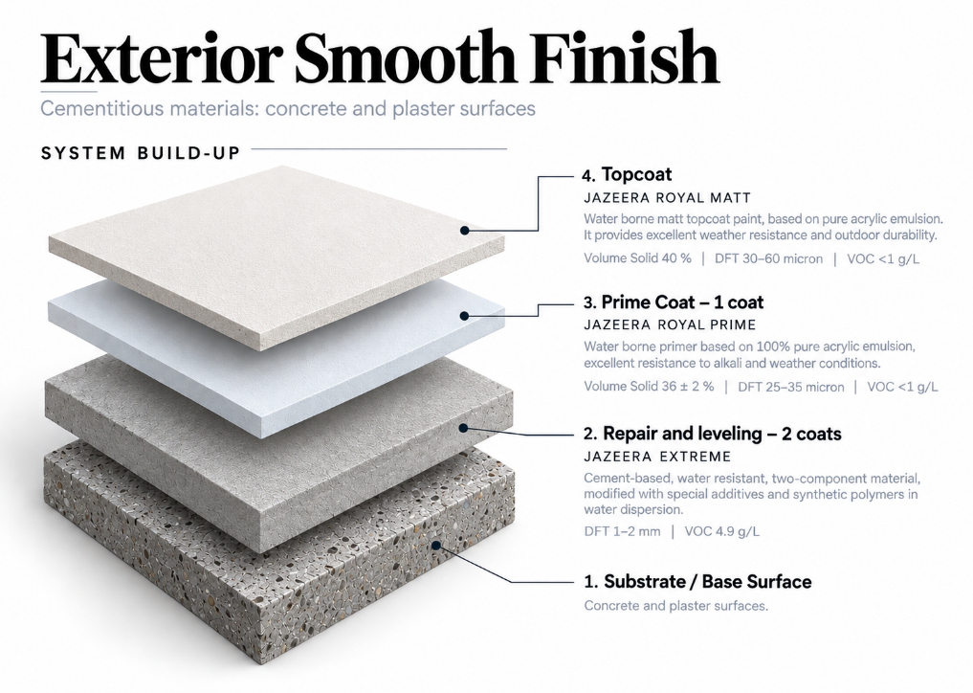
Exterior Smooth Finish

b. Water based, Anti-carbonation smooth finish:
1) Repair and leveling: 2 coats of JAZEERA EXTREME ; Cement-based, water resistant, two-component, modified with special additives and synthetic polymers in water dispersion. / DFT 1-2 mm / VOC 4.9 g/L
2) Prime Coat: 1 coat of Jazeera Silane Primer : Solvent borne clear primer, based on silane-siloxane and acrylic, superior durability and high resistance to alkali, excellent resistance to alkali and weather conditions , Volume Solid 10 ± 2% / DFT 10-12.5 micron / VOC 771 g/L.
3) Topcoat: 2 coats of Jazeera Royal Grand: Water borne 100% pure acrylic elastomeric and anti-carbonation eggshell topcoat paint, characterized by crack-bridging ability and resistance to alkali, moisture and salts. Also excellent flame spread resistant, allows water vapor to pass from the substrate through the paint film and has water repellent property. Volume Solid 53 % / DFT 50-100 micron each coat / VOC <1 g/L
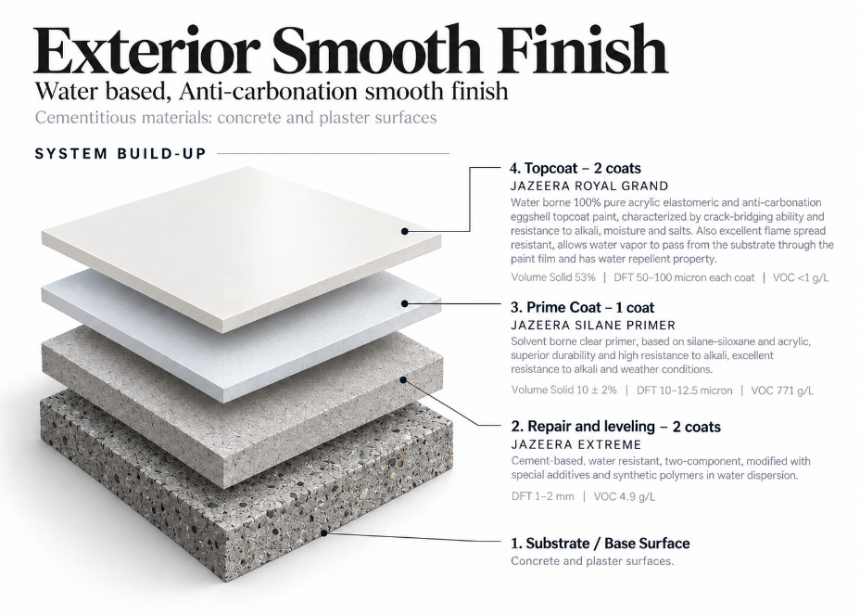

EXT-CR-02 — EXTERIOR TEXTURED
PROJECT FIELD | SELECTION
Project | [INSERT PROJECT REQUIREMENT]
Area of use | [INSERT PROJECT FAÇADE / EXTERIOR AREA]
Substrate | [SELECT ONE: Concrete / Plaster / Masonry / other substrate supported by selected TDS]
Finish | [SELECT ONE: Textured / Spray Finish]
Color | [INSERT PROJECT REQUIREMENT]
Sheen / texture | [SELECT ONE]
Performance | [EDIT TO SUIT PROJECT]

Exterior Texture Finish
A. Cementitious Materials: Concrete and plaster surfaces:
a. Water based, Matt Finish Texture:
1) Repair and leveling: 2 coats of JAZEERA EXTREME : Cement-based, water resistant, two-component, modified with special additives and synthetic polymers in water dispersion./ DFT 1-2 mm / VOC 4.9 g/L
2) Prime Coat: 1 coat of JAZEERA EXTERIOR PRIMER : Water borne primer based on acrylic copolymer emulsion, excellent resistance to alkali and weather conditions.
Volume Solid 29.8 % / DFT 30 micron / VOC <1 g/L
3) Topcoat: JAZEERA NEWTEX PRO : Water borne topcoat with texture appearance, based on acrylic emulsion gives smooth, strong and homogeneous long furrows line in a single coat with attractive and elegant decorative finish. Volume Solid 80 % / DFT 1600 micron / VOC <1 g/L
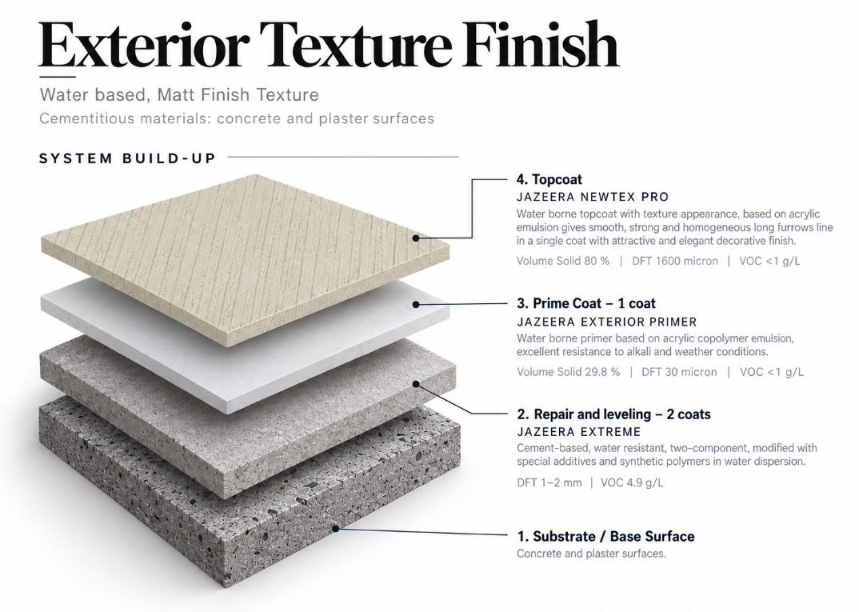

b. MASHASHCO Traditional Texture Finish
1) Prime Coat: 1 coat of JAZEERA ROYAL PRIME
Water borne primer based on 100% pure acrylic emulsion, excellent resistance to alkali and weather conditions.
Volume Solid 36 ± 2 % / DFT 25–35 micron / VOC <1 g/L
2) Topcoat: 1 coat of JAZEERA MASHASHCO
A two-component traditional decorative coat, based on acrylic polymer, providing the old clay houses design. It has a traditional pattern similar to old clay houses with an attractive finish, can be formed in different designs with a beautiful appearance, has high resistance to different weather conditions, and offers excellent adhesion and high durability.
DFT 600–1000 µm / Volume Solid 60 % / Spreading Rate 0.32–0.54 m²/kg / VOC <1 g/L Surface Dry 2 hrs / Hard Dry 48 hrs
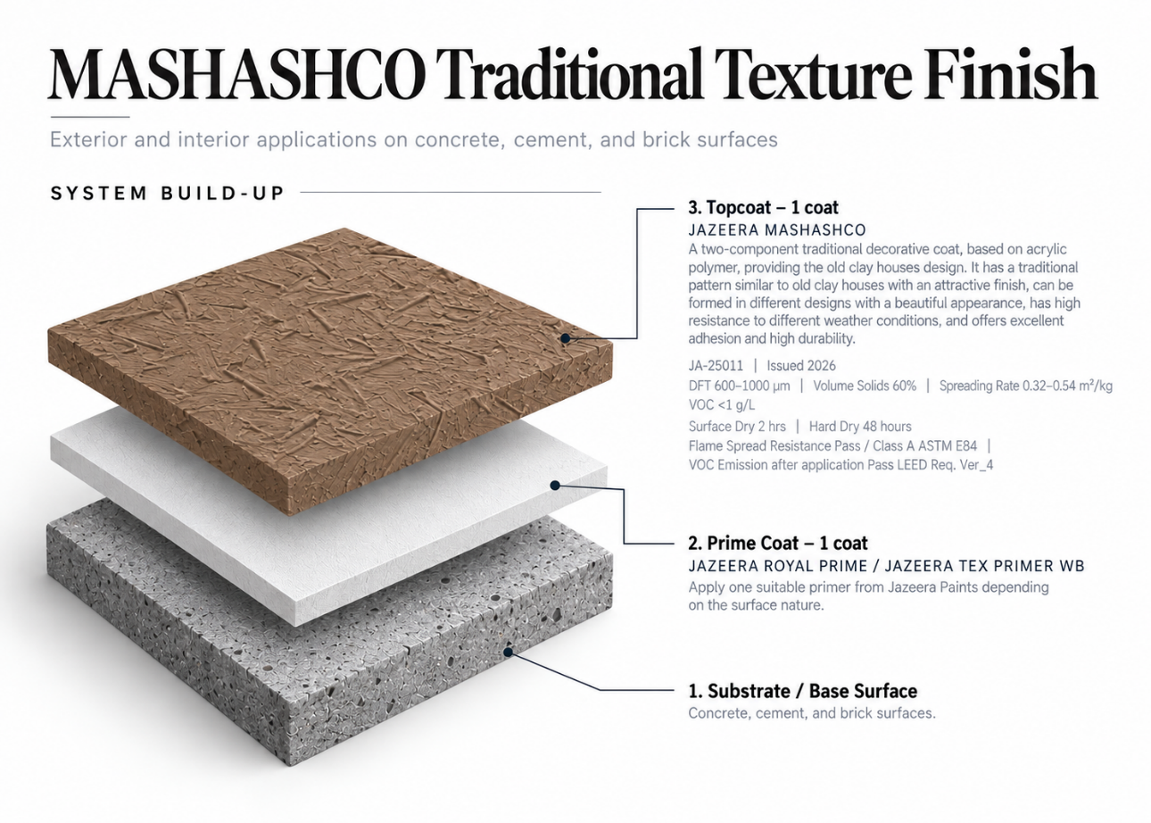

JAZEERA MAROTEX
1. Substrate / Base Surface
Concrete, cement, and brick surfaces.
2. Prime Coat – 1 coat
JAZEERA ROYAL PRIME / JAZEERA TEX PRIMER WB
Apply one coat of Jazeera Royal Prime or Jazeera Tex Primer / WB, or any other suitable primer from Jazeera Paints, depending on the surface nature.
3. Topcoat – 1 coat
JAZEERA MAROTEX
Fine textured paint, based on pure acrylic emulsion, applied by trowel. Suitable for exterior and interior applications for educational institutions, residential, commercial, and industrial buildings. Anti-carbonation property, excellent resistance to UV and harsh weather conditions, and fills and hides hairline cracks.
JA-25051 / Issued 2026
DFT 600–1000 µm / Volume Solids 60 % / Spreading Rate 0.4–0.6 m²/kg / VOC 10.85 g/L
Surface Dry 2 hrs / Hard Dry 24 hours
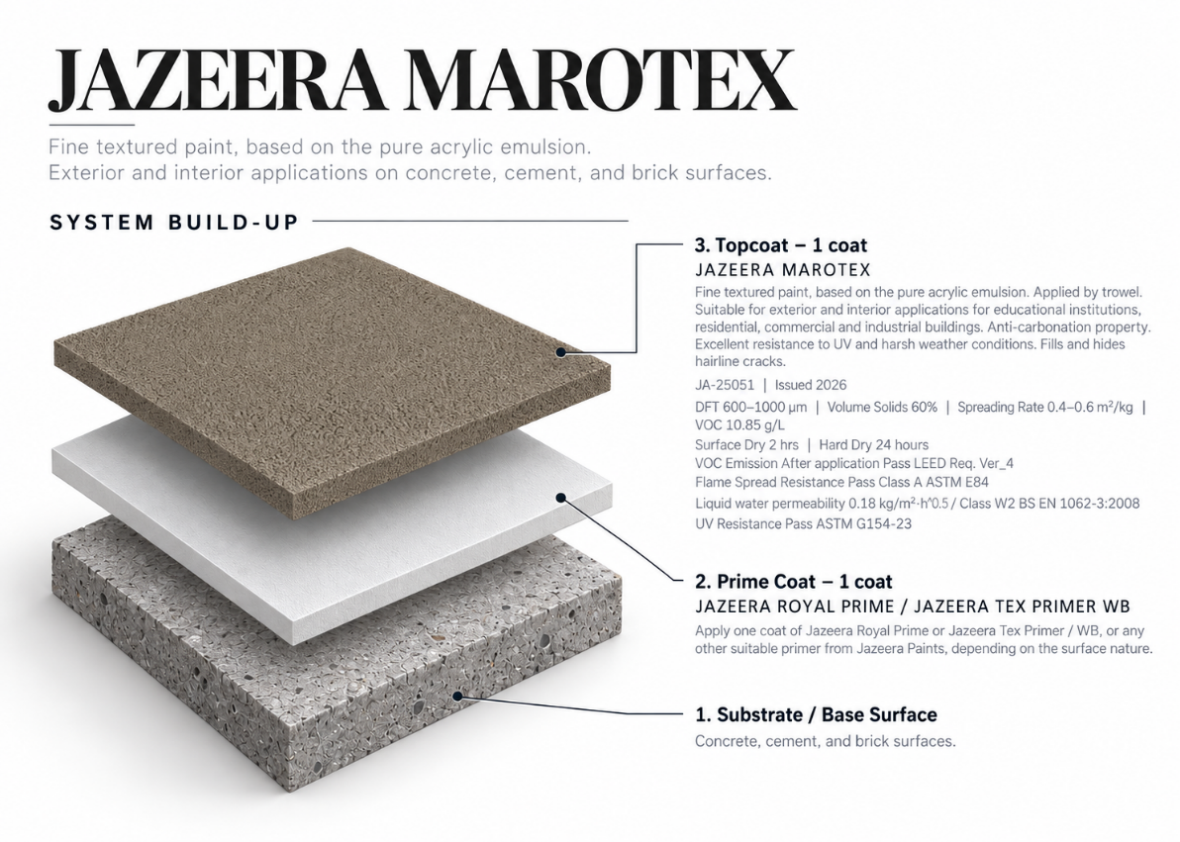

EXT-CR-03 — PRODUCT-SPECIFIC SYSTEM TEMPLATE
Use this controlled template only after selecting one complete product row/system from the retained Technical Evidence Register and obtaining confirmation where required.

CLAUSE FIELD | COPY / EDIT INSTRUCTION
System code | [INSERT CONFIRMED SYSTEM CODE]
Area / substrate | [EDIT TO SUIT PROJECT] using only supported substrates
Primer | Copy exact confirmed primer name, coat count and data
Intermediate coat | Copy exact confirmed intermediate coat/putty, coat count and data; [DELETE IF NOT REQUIRED]
Topcoat | Copy exact confirmed product name, coat count and data
Thickness | Copy exact confirmed DFT/build from current TDS
Coverage | Copy exact confirmed spreading rate/coverage from current TDS
Application | Copy exact method and conditions from current TDS
Performance | Retain only substantiated tests/claims required by the project
Close-out | Append the retained Part 3 inspection, preparation, application, cleaning and protection clauses

SUSTAINABILITY AND SPECIAL-FINISH SUPPORT
Jazeera Paints products and supporting documentation achieving LEED Requirements - Ver_4, compliance pathway, project scope, and availability of current supporting documentation.
Jazeera Paints also offers a range of specialist decorative and special-effect finishes, including clay-inspired, stone-look, ornamental, and textured finishes. Contact Jazeera Paints specialists to obtain the current product range, samples, technical information, and approved system recommendations before specifying these finishes.
FINAL PUBLICATION CHECK
☐ All Priority 0 / technical-confirmation items are closed and recorded.
☐ One complete system is selected for each use/location; unused alternatives are deleted.
☐ Current TDS references, product codes, dates, coat counts, thicknesses, coverage and application data are verified.
☐ Part 1 / Part 2 / Part 3 references are consistent.
☐ Document number, revision, status, approvals, Word output and PDF output are controlled.
☐ Arabic and English versions, if published, are technically equivalent and use identical system/product/value references.
☐ Technical Services, QA/Document Control, Sustainability/Legal (as applicable), Arabic Technical Review and final approver have signed off.

AUTHORITATIVE SOURCE CONTENT — PRESERVED
The original CSI Part 1 – General, Part 2 – Products, Technical Evidence Register, and Part 3 – Execution sections are provided below. Technical text and product evidence have been retained from the attached source file.
The preceding guide shall be used as the navigation, selection, and editing framework. Any editorial changes shall not alter the verified technical intent or product requirements.
Publication shall not proceed until all applicable items in the Technical Confirmation Register have been technically reviewed, supporting evidence has been verified, and the register has been formally closed.

2- Extracted Technical Evidence from Attached TDS

Ref. | Attached filename |  | Type | Product / code | Document / date | Supported evidence | Substrate | Control decision | DFT | VS | Spreading rate | Build | VOC | Recoat / cure
FILLERS
S01 | JAZEERA CRACK FILLER |  | Two-components filler for filling cracks and pores of concrete and cement surfaces, based on acrylic emulsion | JA-12001 | Issued 2026 | For exterior and interior applications for filling small cracks up to 1 cm and holes of. | Concrete, cement and brick surfaces | Surface-repair accessory,  Painting System:  • Apply “Jazeera Crack Filler” until the cracks are filled completely and the surface becomes levelled | Filling Range Up to 1 cm | 50 % | Depends on application | 1coat | NA | • Surface dry  2 hrs.  • Recoating interval 8 hrs (minimum).  • Full cure 24 hrs.
S02 | JAZEERA ULTIMATE |  | Light weight filler, easy to apply based on an innovative emulsion | JA-12005 | Issued 2026 | For exterior and interior applications to repair small holes and cracks | Concrete, plaster, gypsum, and bricks surfaces | Suitable accessory candidate; TDS states it is not a levelling putty or joint filler.  Painting System:  • Apply one coat of “Jazeera Ultimate” to fill the cracks and small holes  • Paintable for all type of paints (water base or solvent based) | Filling Range up to 2 cm wide and 2 cm depth. | 70 % | Depends on application | 1coat | NA | • Surface dry (3-4) hrs.  • Full dry 24 hrs.  • Recoating interval (48-72) hrs.
S03 | JAZEERA EPOXY CRACK FILLER 400 |  | A high quality two-component repair putty, solvent free, based on epoxy polyamide cured which has been modified to fill the hollow spaces  and cracks. | JI-62015 | Issued 2026 | Filler to fill up cracks, pores and hollows, as well as for repairs purposes, in exterior and interior applications. | Concrete, cement, gypsum, wood and steel surfaces | Project-specific repair accessory; confirm topcoat compatibility.  Painting System:  Fill pores, hollows and cracks with “Jazeera Epoxy Crack Filler 400” until the surface becomes leveled and smooth. | Filling Range 0.5–2 cm | 100 % | Depends on application | 1coat | 9.15 g/L | • Surface dry 5hrs.  • Recoating Interval 7 hours (minimum)  • Full cure  7 days.
S04 | JAZEERA UNIQUE FILLER |  | Light weight, two components, solvent free epoxy filler for horizontal and vertical joints | JI-62008 | Issued 2026 | For exterior and interior applications for vertical and horizontal cracks and joints | Concrete and cement substrates,  such as columns, walls, ceilings of buildings and facilities etc. | Special repair accessory; not a substitute for Green Putty.  Painting System:  • Apply “Jazeera Unique Filler” to fill large cracks or joints  • Apply any of epoxy or solvent based or water based topcoats | Filling Range up to 4 cm width and 8 cm depth | 100 % | Depends on application | 1coat | <1 g/L | • Surface dry 2hrs.  •Hard dry 4-6 hrs.  •Recovering overcoating interval 24 hrs.
S05 | JAZEERA UNIQUE JOINT |  | Two component epoxy based light weight filler, specially formulated to seal joints between cement boards and concrete panels | JI-62012 | Issued 2026 | For exterior and interior applications for filling joints between cement boards and concrete panels.  Also for sealing  surface cracks, pores and patching the boards’ fastening screws. | Cement boards, concrete panels | Joint-treatment  Application Method  •Over joints application:  -Install self-sticking fiberglass tape on the joint.  -Apply Jazeera Unique Joint by putty blade or any suitable tool_  •For sealing surface cracks & pores:  -Apply Jazeera Unique Joint by putty knife or any suitable tool after mixing directly:  •For Exterior Applications:  -The topcoats paints should be applied after 7 days of application.  -Start sanding after 24 hours of application | Filling Range 0.5–2 mm | 100 % | Depends on application | 1coat | <1 g/L | • Surface dry  2hrs.  • Hard dry  2-4 hrs.  • To achieve mechanical & chemical resistance:  7 days
 |  | SKIM COAT
S01 | JAZEERA EXTREME |  | cement-based, water resistant, two-component system, fairing, levelling and repairing coat to all concrete and plastered  surfaces, modified with special additives and synthetic polymers in water dispersion. | JK-12001 | Issued 2024 | Levelling and smoothing of all exterior surfaces including the horizontal and vertical ones like concrete, plastered surfaces in buildings, bridges, tunnels and concrete pillars  Flame Spread Resistance Test Class A  VOC Emission After Application: Pass LEED Requirements Ver_4 | concrete, plastered surfaces | Recommended System:  • Apply two coats of “Jazeera Extreme”  • Apply any exterior painting system. | 1-2 mm | 100 % | 1.0 kg/m²/mm | 2coats | 4.9 g/L. | cured with soft water spray after 12 hours from application for the first two days.
S02 | JAZEERA MATRIX EX |  | single component, polymer modified, water resistant, Fine cementitious mortar. | JK-13007 | Issued 2026 | Leveling and smoothing of all exterior surfaces including concrete surfaces, pillars and exterior plastered surfaces for walls and  Ceilings.  VOC Emission After Application: Pass LEED Requirements Ver_4 | concrete, plastered surfaces | Recommended System:  • Apply two coats of “Jazeera Matrix EX”  • Apply any exterior finish coat. | 1-2 mm | 100 % | 0.5-1.0 kg/m²/mm | 2coats | 26.8 g/L. | cured with soft water spray after 12 hours from application for the first two days.
PRIMERS
S01 | JAZEERA ROYAL PRIME |  | Water borne primer based on 100% pure acrylic emulsion | JA-11021 | Issued 2026 | Exterior applications. provides a complete system with good adhesion and high durability.  -Meets MPI Standard # 3  -VOC Emission After Application: Pass LEED Requirements Ver_4  -SASO standard 2060/2018 | Concrete, cement, gypsum and brick surfaces | Best-supported candidate exterior primer  Painting System:  -Apply one coat of "Jazeera Royal Prime"  -Apply any exterior water based paint from Jazeera Paints. | 25-35 µ. | 36 ±2 % | 10.3-14.4 m²/L | 1coat | <0.1 g/L. | • Surface dry 30 minutes.  • Hard dry 2 hrs.  • Recoating interval 4 hours. (minimum)
S02 | JAZEERA EXTERIOR PRIMER |  | Water borne primer based on acrylic copolymer emulsion, | JA-11030 | Issued 2025 | Exterior applications as a primer for educational institutions,  residential, commercial and industrial buildings. | Concrete, cement, gypsum and brick surfaces | Apply one coat of "Jazeera Exterior Primer".  Apply any exterior water based architectural painting system from Jazeera Paints. | 30 µ. | 29.8 % | 9.93 m²/L | 1coat | <0.1 g/L. | • Surface dry 30 minutes.  • Hard dry 2 hrs.  • Recoating interval 4 hours. (minimum)
S03 | JAZEERA TEX PRIMER WB |  | Water-based primer, based on a special acrylic copolymer emulsion | JA-11030B | Issued 2026 | interior and exterior applications an ideal primer for new surfaces, where exceptional coverage for surface defects is required  VOC Emission After Application: Pass LEED Requirements Ver_4 | concrete, cement, gypsum, wood, and brick surfaces | Painting System:  •Apply one coat of "Jazeera Tex Primer WB”  • Apply any topcoats that applied by trowel or spray from Jazeera Paints. | 30-50 µ. | 34 % | 6.8 – 9.7 m²/L | 1coat | 34.5 g/L | • Surface dry 30 minutes.  • Hard dry 4 hrs.  • Recoating interval 4 hours. (minimum)
S04 | JAZEERA TEX PRIMER |  | Solvent based sealer and primer, based on a special synthetic copolymer, | JA-41006 | Issued 2026 | interior and exterior applications an ideal primer for new surfaces, where exceptional coverage for surface defects is required | concrete, cement, gypsum, wood, and brick surfaces | Painting System:  •Apply one coat of "Jazeera Tex Primer”  • Apply any topcoats that applied by trowel or spray from Jazeera Paints. | 60-70 µ. | 47 % | 6.7 – 7.8 m²/L | 1coat | 446 g/L | • Surface dry 30 minutes.  • Hard dry 4 hrs.  • Recoating interval 4 hours. (minimum)
S05 | JAZEERA BLOCKING PRIMER.pdf |  | Solvent based primer and sealer, based on a special synthetic copolymer | JA-41005 | Issued 2026 | Interior and exterior applications. It is considered the ideal primer in case of maintenance | Concrete, cement plasters and gypsum surfaces | special/maintenance primer. | 40 µ. | 37 % | 9.25 m²/L | 1coat | 529 g/L. | • Surface dry 30 minutes.  • Hard dry 4 hrs.  • Recoating interval 4 hours. (minimum)
S06 | JAZEERA C PRIMER |  | Solvent base, clear primer, based on acrylic resin | JA-41001 | Issued 2026 | Exterior and interior application, It is specially recommended to resist alkali and moisture  Termite Resistance: Pass | Concrete, cement plasters and gypsum surfaces | Candidate special option only;  •Apply one coat of "Jazeera Blocking Primer”  •Apply any of interior or exterior architectural painting system from Jazeera Paints. | 15-25 µ. | 17 % | 6.8 - 11.3 m²/L | 1coat | NA | • Surface dry 30 minutes.  • Hard dry 1 hr.  • Recoating interval 2 hrs. (minimum)
S07 | JAZEERA MAX PRIMER |  | Water borne primer based on special acrylic polymer | JA-11031 | Issued 2026 | Exterior and interior application, It is recommended for double hiding. | Concrete, cement plasters and gypsum surfaces | •Apply one coat of "Jazeera Max Primer”  •Apply any of interior or exterior architectural painting system from Jazeera Paints. | 25 µ. | 46.48 % | 18.6 m²/L | 1coat | NA | • Surface dry 30 minutes.  • Hard dry 2 hrs.  • Recoating interval 4 hrs. (minimum)
S08 | JAZEERA SILANE PRIMER |  | Solvent borne clear primer, based on silane-siloxane and acrylic | JA-41003 | Issued 2026 | Exterior and interior application, It is specially recommended to protect the concrete structures from attack by acid gases, chloride ions and water. | concrete, cement, and brick surfaces | Special-purpose candidate only; system purpose/finish  •Apply one coat of "Jazeera C Primer”  •Apply any of interior or exterior architectural painting system from Jazeera Paints. | 10 µ. | 10 ± 2 % | 10 m²/L | 1coat | VOC 771 g/L | • Surface dry 3 hrs.  • Hard dry 6 hrs.  • Recoating interval 6 hrs. (minimum)
 |  | PLAIN EMULSION EXTERIOR TOPCOATS
S01 | JAZEERA ROYAL MATT |  | Water borne matt topcoat paint, based on pure acrylic emulsion | JA-15032 | Issued 2026 | Exterior applications for educational institutions, residential, commercial and industrial buildings. Also it can be applied over textures.  -Excellent resistance to UV and weather conditions.  -Resistance to dirt pick up  -VOC Emission After application Pass LEED Req. Ver_4  - SASO GSO 2582_2022  -Meets MPI #10  -Artificial Weathering Resistance Pass 2500 hrs BS EN 1062-11/ ISO 11507-2007 | concrete, cement, and brick surfaces | Painting System:  • Apply one coat of "Jazeera Royal Prime" or any other suitable primer from Jazeera Paints depending on the surface nature.  • Apply two coats of "Jazeera Royal Matt" | 30-60 µ | 40 % | 6.65-13.3 m²/L | 2  coats | <1 g/L | Surface dry 30 minutes  Hard dry 2 hours  Recoating interval  4 hrs (minimum)
S02 | JAZEERA ROYAL SILK |  | Water borne silk topcoat paint, based on pure acrylic emulsion | JA-16052 | Issued 2026 | Exterior applications for educational institutions, residential, commercial and industrial buildings. Also it can be applied over textures.  -Excellent resistance to UV and weather conditions.  - High anti-carbonation  -Resistance to dirt pick up  -VOC Emission After application Pass LEED Req. Ver_4  - SASO GSO 2582_2022  • Crack-Bridging Ability Pass crack width 2.2mm EN 1062-7:2004  • UV Resistance Pass ASTM G154-23  • Carbon Dioxide Permeability Test (BS EN 1062-6_2002 Method A) | concrete, cement, and brick surfaces | Painting System:  • Apply one coat of "Jazeera Royal Prime" or any other suitable primer from Jazeera Paints depending on the surface nature.  • Apply two coats of "Jazeera Royal Silk" | 30-50 µ | 40 % | 8-13.3 m²/L | 2  coats | <1 g/L | Surface dry 30 minutes  Hard dry 4 hours  Recoating interval  8 hrs (minimum)
S03 | JAZEERA ROYAL SEMIGLOSS |  | Water borne semi gloss topcoat paint, based on pure acrylic emulsion | JA-17013 | Issued 2026 | Exterior applications for educational institutions, residential, commercial and industrial buildings. Also it can be applied over textures.  -Excellent resistance to UV and weather conditions.  -Resistance to dirt pick up  -VOC Emission After application Pass LEED Req. Ver_4  - SASO GSO 2582_2022  Meets MPI #11 | concrete, cement, and brick surfaces | Painting System:  • Apply one coat of "Jazeera Royal Prime" or any other suitable primer from Jazeera Paints depending on the surface nature.  • Apply two coats of "Jazeera Royal Semigloss" | 40 µ | 36 % | 9 m²/L | 2  coats | 3.7 g/L | Surface dry 1 hr  Hard dry 4 hours  Recoating interval  8 hrs (minimum)
S04 | JAZEERA ROYAL GLOSS |  | Water borne gloss topcoat paint, based on pure acrylic emulsion | JA-18016 | Issued 2026 | Exterior applications for educational institutions, residential, commercial and industrial buildings. Also it can be applied over textures.  -Excellent resistance to UV and weather conditions.  -Resistance to dirt pick up  -VOC Emission After application Pass LEED Req. Ver_4  - SASO GSO 2582_2022 | concrete, cement, and brick surfaces | Painting System:  • Apply one coat of "Jazeera Royal Prime" or any other suitable primer from Jazeera Paints depending on the surface nature.  • Apply two coats of "Jazeera Royal Gloss" | 40 µ | 39 % | 9.75 m²/L | 2  coats | <1 g/L | Surface dry 1 hr  Hard dry 4 hours  Recoating interval  8 hrs (minimum)
S05 | JAZEERA ROYALTEX |  | Water borne matt topcoat paint based one 100% pure acrylic | JA-25052 | Issued 2026 | Exterior applications for educational institutions, residential, commercial and industrial buildings. Also it can be applied over textures.  -Excellent resistance to UV and weather conditions.  -Resistance to dirt pick up | concrete, cement, and brick surfaces | Painting System:  • Apply one coat of "Jazeera Royal Prime" or any other suitable primer from Jazeera Paints depending on the surface nature.  • Apply two coats of "Jazeera Royaltex" | 30-60 µ | 38±2 % | 6.33–12.67  m²/L | 2  coats | NA | Surface dry 30 minutes  Hard dry 2 hours  Recoating interval  4 hrs (minimum)
S06 | JAZEERA EMPEROR |  | water-based matt paint based on acrylic emulsion.  It provides the surface a very brilliant Whiteness | JA-15003 | Issued 2026 | Exterior applications. It is highly recommended  for that area where weather resistance is very important. Also it can be applied for interior applications.  -Excellent resistance to weather conditions.  -Excellent resistance to UV.  -Excellent hiding and adhesion  -Excellent color retention  -Excellent hiding  -Excellent resistance to scrub and water | concrete, cement, gypsum, hard board and brick surfaces | Painting System:  • Apply one coat of "Jazeera Royal Prime" or any other suitable primer from Jazeera Paints depending on the surface nature.  • Apply two coats of "Jazeera Emperor" | 40 µ | 36 % | 9 m²/L | 2  coats | NA | Surface dry 30 minutes  Hard dry 2 hours  Recoating interval  4 hrs (minimum)
S07 | JAZEERA EXTERIOR EMULSION |  | Water borne matt topcoat paint, based on acrylic copolymer emulsion | JA-15047 | Issued 2025 | Exterior applications for educational institutions, residential, commercial and industrial buildings. Also it can be applied over textures. | concrete, cement, and brick surfaces | Painting System:  • Apply one coat of "Jazeera Exterior Primer" or any other suitable primer from Jazeera Paints depending on the surface nature.  • Apply two coats of "Jazeera Exterior Emulsion" | 30 µ | 35 % | 11.66 m²/L | 2  coats | <1 g/L | Surface dry 30 minutes  Hard dry 2 hours  Recoating interval  4 hrs (minimum)
 |  | HIGH PERFORMANCE EXTERIOR TOPCOATS
S01 | JAZEERA DIYAR MATT |  | High performance matt water-based topcoat paint, based on a special type of acrylic polymer, designed with innovative technology | JA-15036 | Issued 2026 | Exterior applications for educational institutions, residential, commercial and industrial buildings. Also it can be applied over textures.  -Superior resistance to rainwater marks.  -Excellent anti-carbonation.  -Smart clean technology with excellent resistance to dust and dirt pickup.  -Exceptional resistance to acid rain, salts, and alkalis.  -Self-priming.  -High protection against harsh weather conditions and UV.  -Excellent solar reflectance.  -Reduces indoor building temperatures.  -Conceals hairline cracks  -High durability and hardness  -Superior hiding.  -Excellent penetration into surface pores.  -VOC Emission After application Pass LEED Req. Ver_4  -Solar Reflectance 71% ASTM E903-20  -Thermal Emittance 0.88 ASTM C1371-15 (2022)  -Carbon Dioxide Permeability  (BS EN 1062-6_2002 Method A)  PASS | concrete, cement, and brick surfaces | Painting System:  - Apply two coats of "Jazeera DIYAR Matt" directly on the surface  - For smooth precast and brick surface, or maintenance it is recommended to apply one coat of "Jazeera Blocking Primer" before topcoat | 40 µ | 42% | 10.5 m²/L | 2  coats | <1 g/L | Surface dry 1 hr  Hard dry 4 hours  Recoating interval  8 hrs (minimum)
S02 | JAZEERA DIYAR SILK |  | High performance silk water-based topcoat paint, based on a special type of acrylic polymer, designed with innovative technology | JA- 16053 | Issued 2026 | Exterior applications for educational institutions, residential, commercial and industrial buildings. Also it can be applied over textures.  -Superior resistance to rainwater marks.  -Excellent anti-carbonation.  -Smart clean technology with excellent resistance to dust and dirt pickup.  -Exceptional resistance to acid rain, salts, and alkalis.  -Self-priming.  -High protection against harsh weather conditions and UV.  -Excellent solar reflectance.  -Reduces indoor building temperatures.  -Conceals hairline cracks  -High durability and hardness  -Superior hiding.  -Excellent penetration into surface pores.  -VOC Emission After application Pass LEED Req. Ver_4  -Solar Reflectance 74% ASTM E903-20  -Thermal Emittance 0.88 ASTM C1371-15 (2022)  -Carbon Dioxide Permeability  (BS EN 1062-6_2002 Method A)  PASS | concrete, cement, and brick surfaces | Painting System:  - Apply two coats of "Jazeera DIYAR Silk" directly on the surface  - For smooth precast and brick surface, or maintenance it is recommended to apply one coat of "Jazeera Blocking Primer" before topcoat | 40 µ | 43 % | 10.75 m²/L | 2  coats | <1 g/L | Surface dry 1 hr  Hard dry 4 hours  Recoating interval  8 hrs (minimum)
S03 | JAZEERA DIYAR SEMIGLOSS |  | High performance semi gloss water-based topcoat paint, based on a special type of acrylic polymer, designed with innovative technology | JA-17014 | Issued 2026 | Exterior applications for educational institutions, residential, commercial and industrial buildings. Also it can be applied over textures.  -Superior resistance to rainwater marks.  -Excellent anti-carbonation.  -Smart clean technology with excellent resistance to dust and dirt pickup.  -Exceptional resistance to acid rain, salts, and alkalis.  -Self-priming.  -High protection against harsh weather conditions and UV.  -Conceals hairline cracks  -High durability and hardness  -Superior hiding.  -Excellent penetration into surface pores. | concrete, cement, and brick surfaces | Painting System:  - Apply two coats of "Jazeera DIYAR Semigloss" directly on the surface  - For smooth precast and brick surface, or maintenance it is recommended to apply one coat of "Jazeera Blocking Primer" before topcoat | 40 µ | 36 % | 9 m²/L | 2  coats | NA | Surface dry 1 hr  Hard dry 4 hours  Recoating interval  8 hrs (minimum)
S04 | JAZEERA DIYAR GLOSS |  | High performance gloss water-based topcoat paint, based on a special type of acrylic polymer, designed with innovative technology | JA-18015 | Issued 2026 | Exterior applications for educational institutions, residential, commercial and industrial buildings. Also it can be applied over textures.  -Superior resistance to rainwater marks.  -Excellent anti-carbonation.  -Smart clean technology with excellent resistance to dust and dirt pickup.  -Exceptional resistance to acid rain, salts, and alkalis.  -Self-priming.  -High protection against harsh weather conditions and UV.  -Conceals hairline cracks  -High durability and hardness  -Superior hiding.  -Excellent penetration into surface pores. | concrete, cement, and brick surfaces | Painting System:  - Apply two coats of "Jazeera DIYAR Gloss" directly on the surface  - For smooth precast and brick surface, or maintenance it is recommended to apply one coat of "Jazeera Blocking Primer" before topcoat | 40 µ | 45 % | 11.25 m²/L | 2  coats | NA | Surface dry 1 hr  Hard dry 4 hours  Recoating interval  8 hrs (minimum)
 |  | EXTERIOR TEXTURES TOPCOATS
S01 | JAZEERA LINETEX |  | High performance matt topcoat textured paint, based on acrylic emulsion_ It gives strong, homogeneous and attractive lines in a single coat | JA-25009 | Issued 2026 | Exterior and interior applications for educational institutions, residential, commercial and industrial buildings.  -High resistance to moisture, temperature and harsh weather conditions.  -High resistance to scratch and friction.  -VOC Emission After application Pass LEED Req. Ver_4  -SASO standard GSO 2592/2022 | concrete, cement, and brick surfaces | Painting System:  •Apply one coat of “Jazeera Royal Prime" or ”Jazeera Tex Primer / WB” or any other suitable primer from Jazeera Paints, depending on the  surface nature.  • Apply one coat of "Jazeera Linetex" by trowel. | 3000 µ | 80 % | 0.27 m²/Kg | 1  coat | 14.9 g/L | Surface dry 2 hrs  Hard dry 24 hours
S02 | JAZEERA NEWTEX |  | High performance matt topcoat textured paint, based on acrylic emulsion_ It gives smooth, strong, homogenous and attractive finish in a single coat with long furrows lines | JA-25033 | Issued 2026 | Exterior and interior applications for educational institutions, residential, commercial and industrial buildings.  -High resistance to moisture, temperature and harsh weather conditions.  -High resistance to scratch and friction.  -VOC Emission After application Pass LEED Req. Ver_4  -SASO standard GSO 2592/2022 | concrete, cement, and brick surfaces | Painting System:  •Apply one coat of “Jazeera Royal Prime" or ”Jazeera Tex Primer / WB” or any other suitable primer from Jazeera Paints, depending on the  surface nature.  • Apply one coat of "Jazeera Newtex" by trowel. | 2000 µ | 80 % | 0.4 m²/Kg | 1  coat | 38.97 g/L | Surface dry 2 hrs  Hard dry 24 hours
S03 | JAZEERA NEWTEX PRO |  | Texture topcoat appearance, based on acrylic emulsion. It gives smooth, strong, homogeneous long furrows line in a  single coat | JA-25063 | Issued 2026 | Exterior and interior applications for educational institutions, residential, commercial and industrial buildings.  -High resistance to moisture, temperature and harsh weather conditions.  -High resistance to scratch and friction.  -VOC Emission After application Pass LEED Req. Ver_4 | concrete, cement, and brick surfaces | Painting System:  •Apply one coat of “Jazeera Exterior Primer" or ”Jazeera Tex Primer / WB” or any other suitable primer from Jazeera Paints, depending on the  surface nature.  • Apply one coat of "Jazeera Newtex PRO" by trowel. | 1600 µ | 80 % | 0.27 m²/Kg | 1  coat | <1  g/L | Surface dry 2 hrs  Hard dry 24 hours
S04 | JAZEERA NEWTEX PRO FINE |  | Texture topcoat with appearance, based on acrylic emulsion. It imparts surfaces a smooth, strong, homogenous finish | JA-25082 | Issued 2026 | Exterior and interior applications for educational institutions, residential, commercial and industrial buildings.  -High resistance to moisture, temperature and harsh weather conditions.  -High resistance to scratch and friction. | concrete, cement, and brick surfaces | Painting System:  •Apply one coat of “Jazeera Exterior Primer" or ”Jazeera Tex Primer / WB” or any other suitable primer from Jazeera Paints, depending on the  surface nature.  • Apply one coat of "Jazeera Newtex PRO Fine" by trowel. | 1350 µ | 67 % | 0.5 m²/Kg | 1  coat | 33.24g/L | Surface dry 2 hrs  Hard dry 24 hours
S05 | JAZEERA RUSTIC |  | Fine textured masonry paint based on tailor-made emulsion. | JA-25066 | Issued 2026 | Exterior and interior applications for educational institutions, residential, commercial and industrial buildings.  -Excellent resistance to UV and harsh weather conditions_  -Crack-bridging ability and fills hairline cracks  -Water vapor permeable  -Anti-carbonation property  -Superior scrub resistance  -VOC Emission After application Pass LEED Req. Ver_4  -Water Resistance Pass ASTM D4585/D4585M-18  -Chemical Resistance Pass ISO 2812-1_2017  -Scrub Resistance Pass ASTM D2486-17  -Carbon Dioxide Permeability Test (BS EN 1062-6_2002 Method A) | concrete, cement, and brick surfaces | Painting System:  •Apply one coat of “Jazeera Royal Prime" or ”Jazeera Tex Primer / WB” or any other suitable primer from Jazeera Paints, depending on the  surface nature  • Apply one coat of "Jazeera Rustic" by trowel. | 600-1200 µ | 52 % | 0.3-0.6 m²/Kg | 1  coat | 30 g/L | Surface dry 2 hrs  Hard dry 24 hours
S06 | JAZEERA MAROTEX |  | Fine textured paint, based on the pure acrylic emulsion. | JA- 25051 | Issued 2026 | Exterior and interior applications for educational institutions, residential, commercial and industrial buildings.  -Anti-carbonation property  -Excellent resistance to UV and harsh weather conditions.  Fills and hides hairline cracks  -VOC Emission After application Pass LEED Req. Ver_4  -Flame Spread Resistance Pass Class A ASTM E84 Element  -Liquid water permeability 0_18 kg/m_ -h0_5 / Class W2 BS EN 1062-3_2008  -UV Resistance Pass ASTM G154-23 | concrete, cement, and brick surfaces | Painting System:  •Apply one coat of “Jazeera Royal Prime" or ”Jazeera Tex Primer / WB” or any other suitable primer from Jazeera Paints, depending on the  surface nature  • Apply one coat of " JAZEERA MAROTEX " by trowel. | 600-1000 µ | 60 % | 0.4-0.6 m²/Kg | 1  coat | 10.85 g/L | Surface dry 2 hrs  Hard dry 24 hours
S07 | JAZEERA TEXTURE |  | Rough texture topcoat paint, based on acrylic emulsion | JA-25001 | Issued 2026 | Exterior and interior applications for educational institutions, residential, commercial and industrial buildings.  -High resistance to moisture, temperature and harsh weather conditions.  -Can be formed in different rough texture designs, by roller or spray gun.  -High resistance to scratch and friction.  -VOC Emission After application Pass LEED Req. Ver_4  -SASO standard GSO 2592/2022 | concrete, cement, brick, steel and galvanized steel surfaces | Painting System:  •Apply one coat of “Jazeera Royal Prime" or ”Jazeera Tex Primer / WB” or any other suitable primer from Jazeera Paints, depending on the  surface nature  • Apply one coat of "Jazeera Texture" by texture spray gun or roller. | 1000-2700 µ | 62 % | (0.12 – 0.33) m² / Kg | 1  coat | 45.5 g/L | Surface dry 2 hrs  Hard dry 24 hours
S08 | JAZEERA TEXTURE FINE |  | Rough texture topcoat paint, based on acrylic emulsion | JA-25039 | Issued 2026 | Exterior and interior applications for educational institutions, residential, commercial and industrial buildings.  -High resistance to moisture, temperature and harsh weather conditions.  -High resistance to scratch and friction.  -Can be formed in different texture designs by roller or spray gun. | concrete, cement, brick, steel and galvanized steel surfaces | Painting System:  •Apply one coat of “Jazeera Royal Prime"  • Apply one coat of "Jazeera Texture Fine" using a spray gun or a roller. | 300-500 µ | 52 % | (0.63 – 1) m² / Kg | 1  coat | 51 g/L | Surface dry 2 hrs  Hard dry 24 hours
S09 | JAZEERA SOFTEX INTERIOR / EXTERIOR |  | A soft finish texture paint based on acrylic emulsion provides different pressable granular designs | JA-25079 | Issued 2026 | Exterior and interior applications for educational institutions, residential, commercial and industrial buildings.  -High resistance to different weather conditions.  -Highly durable and excellent adhesion.  -Excellent resistance to water.  -High resistance to abrasion  -VOC Emission After application Pass LEED Req. Ver_4  -SASO standard GSO 2592/2022  -Meets MPI standard # 42 | concrete, cement and brick surfaces | Painting System:  •Apply one coat of “Jazeera Royal Prime" or ”Jazeera Tex Primer / WB” or any other suitable primer from Jazeera Paints, depending on the  surface nature  • Apply one coat of "Jazeera Softex Interior/Exterior"  • Apply 2 coats of "Jazeera Royal Matt / Silk / Semigloss / Gloss" or any suitable exterior topcoats from Jazeera Paints. | 175-450 µ | 55% | 1.0-2.7 m²/Kg | 1  coat | 12.34 g/L | Surface dry 2 hrs  Hard dry 24 hours  For pressing (20 – 30) minutes
S10 | JAZEERA SILKTEX |  | Self-priming paint with a silk texture and smooth-touch topcoat, based on acrylic emulsion_ | JA-26002 | Issued 2026 | Exterior and interior applications for educational institutions, residential, commercial and industrial buildings.  -Self priming texture.  -Excellent durability and high resistance to weather conditions.  -High flexible and excellent adhesion.  -Crack-bridging ability and hide spider net cracks.  -Excellent resistance to water. | concrete, cement, and brick surfaces | Painting System:  • Primer: Self-priming, if required apply one coat of “Jazeera Royal Prime”  • Topcoat:  For Decorative Texture Appearance: Apply one or two coats of “Jazeera Silktex” by using sponge roller.  For Plain Finish: Apply one or two coats of “Jazeera Silktex” by using smooth roller. | 200-400 µ | 38 % | (1.9 – 3.8) m² / L | 1-2  coats | NA | Surface dry 2 hrs  Hard dry 24 hours
S11 | JAZEERA GLOSSTEX |  | Gloss texture with smooth touch topcoat paint, based on acrylic polymer, imparts a glossy beautiful finish with varied decorative  forms which can be designed by the sponge roller | JA-28001 | Issued 2026 | Exterior and interior applications for educational institutions, residential, commercial and industrial buildings.  -Excellent resistance to weather conditions.  -High flexible and excellent adhesion.  -Excellent resistance to water.  -SASO standard GSO 2592/2022 | concrete, cement, and brick surfaces | Painting System:  • Apply one coat of "Jazeera Royal Prime" according to "Jazeera Glosstex" color and leave it to dry.  • Apply one or two coats of "Jazeera Glosstex". | 125-225 µ | 37 % | (1.7 – 3) m² / L | 1-2  coats | NA | Surface dry 2 hrs  Hard dry 24 hours
S12 | JAZ STONE |  | Water borne texture topcoat paint, based on pure acrylic emulsion_ it gives natural beauty and hard stone appearances | JA-25032 | Issued 2026 | Exterior and interior applications for educational institutions, residential, commercial and industrial buildings.  -High resistance to moisture.  -Excellent adhesion_  -High resistance to scratch and friction.  -Excellent durability for harsh Middle East weather conditions.  -SASO standard GSO 2592/2022 | concrete, cement, and brick surfaces | Painting System:  • Apply one coat of "Jazeera Royal Prime"  • Apply two coats of "Jaz Stone" using special spray gun and preferred to leave 72 hours for dry.  • Apply one coat of "Jaz Stone Clear". | 1700-2300 µ | 70 % | 0.16-0.22 m²/Kg | 1coat | NA | Surface dry 2 hrs  Hard dry 72 hours
S13 | JAZEERA SALD |  | Water borne texture topcoat paint, based on pure acrylic emulsion and natural aggregates | JA-25043 | Issued 2026 | Exterior and interior applications for educational institutions, residential, commercial and industrial buildings.  -High resistance to UV.  -High resistance to weather conditions.  -Excellent resistance to alkali and water. | concrete, cement, and brick surfaces | Painting System:  • Apply one coat of ”Jazeera Tex Primer / WB” or “Jazeera Max Primer”  • Apply "Jazeera Sald" with special texture gun  • Press with smooth stainless steel or plastic trowel or plastic roller after touch dry.  • Apply 2 coats of "Jazeera Dura Gloss” after hard dry | 700-1000 µ | 52 % | 0.3-0.43 m²/Kg | 1coat | 32.96 g/L | Surface dry 2 hrs  Hard dry 72 hours
S14 | JAZEERA MASHASHCO |  | A two-component traditional decorative coat, based on acrylic polymer, provides the old clay houses design | JA-25011 | Issued 2026 | Exterior and interior applications for old traditional houses.  -It has traditional pattern same as old clay houses with an attractive finish.  -Can be formed in different designs with a beautiful appearance.  -High resistance to different weather conditions.  -Excellent adhesion and high durability.  -Flame spread resistance Pass / Class A ASTM E84  -VOC Emission After application Pass LEED Req. Ver_4 | concrete, cement, and brick surfaces | Painting System:  •Apply one coat of “Jazeera Royal Prime" or ”Jazeera Tex Primer / WB” or any other suitable primer from Jazeera Paints, depending on the  surface nature  • Apply one coat of "Jazeera Mashashco" | 600-1000 µ | 60 % | 0.32-0.54 m²/Kg | 1coat | <1 g/L | Surface dry 2 hrs  Hard dry 48 hours
 |  | ANTICARBONATION EXTERIOR TOPCOATS
S01 | JAZEERA ROYAL GRAND |  | Water borne, 100% pure acrylic elastomeric and anti-carbonation eggshell topcoat paint. | JA-15016 | Issued 2025 | Protective and decorative topcoat for exterior and interior applications for palaces, houses, car parks, bridges, tunnels and coastal areas buildings. Also it can be applied in wet areas like kitchens and bathrooms.  characterized by crack-bridging ability and resistance to alkali, moisture and salts.  -Water vapor permeable.  -Excellent UV resistance.  -Excellent anti-carbonation property (Carbon Dioxide)  -Long-lasting corrosion protection to reinforced steel in concrete.  -Carbon Dioxide Permeability  (BS EN 1062-6_2002 Method A)  -VOC Emission After application Pass LEED Req. Ver_4  -Abrasion resistance Pass ASTM D4060_2019  -UV Resistance Pass 2500 hrs BS EN 1062-11_2002  -Flame Spread Resistance Class 1 ASTM E84  -Elongation at Break 191 % / ASTM D412  -Light Reflectivity (LRV) / 98_5% / BS 8493_2008  -Crack - Bridging Method B /B4_1 / DIN EN 1062 - 7 /  23°C & No.of cycles 1000 cycles & Max crack width = 0.5 mm  -Tensile strength 6.53 MPa / ASTM 638-22  -Wet Scrub Resistance_ pass 20000 cycles DIN 53778-2_1983  -Water - Vapor Transmission Rate (Permeability) / ISO 7783_2018  Chloride Ion diffusion (cm² /s) 3.9 X 10⁻¹⁰ / ASTM C1556 - 11a (2016)  -Corrosion Resistance Pass ASTM B117-19  • Depth of Penetration of Water Under Pressure Pass BSEN 12390-8-2019  Dirt Collection Index:  Before washing 95% / After washing 97% ASTM D3719 | concrete, cement and other masonry  substrates | Painting System:  For Smooth Surfaces  • Apply one coat of "Jazeera Silane Primer"  • Apply two coats (or more) of "Jazeera Royal Grand"  For Rough Surfaces  • Apply two coats (or more) of "Jazeera Royal Grand" directly on the surface. | 50-100 µ | 53 % | 4-8 m²/L | 2  Coats  or more | < 1 g/L | Surface dry 30 min  Hard dry 4 hours  Recoating interval  8 hrs (minimum)
S02 | JAZEERA ROYAL GRAND SEMIGLOSS |  | Water borne, 100% pure acrylic elastomeric semi gloss paint, anti-carbonation and alkali resistant topcoat | JA-17021 | Issued 2026 | Protective and decorative topcoat for exterior and interior applications on concrete, cement and other masonry  substrates for palaces houses, car parks ,bridges, tunnels and coastal areas buildings. Also it can be applied in wet areas like kitchens and bathrooms.  -Excellent UV resistance_  -Excellent anti-carbonation property (Carbon Dioxide)  -Long lasting corrosion protection to reinforced steel in concrete.  -Water Vapor Transmission Pass ASTM E76/E76M-16  -Water Resistance Pass 24hrs@38°C ASTM D870-15(2020)  / Pass 500hrs@38°C ASTM D1735-14 | concrete, cement and other masonry  substrates | Painting System:  For Smooth Surfaces  • Apply one coat of "Jazeera Silane Primer"  • Apply 2 coats  (or more) of "Jazeera Royal Grand Semigloss"  For Rough Surfaces  • Apply two coats (or more) of "Jazeera Royal Grand" directly on the surface. | 50-100 µ | 43 ±2 % | 4.3 – 8.6 m²/L | 2  Coats  or more | < 1 g/L | Surface dry 30 min  Hard dry 4 hours  Recoating interval  8 hrs (minimum)
S03 | JAZEERA ROYAL GRAND TEX |  | Fine texture flexible topcoat paint, based on 100% pure acrylic emulsion with special aggregates_ Formulated for giving  excellent anti carbonation property. | JA-26005 | Issued 2026 | Formulated for giving  excellent anti carbonation property with maximum durability and high ability to cover cracks, specially designed to apply by sponge roller.  for exterior & interior applications for educational institutions, residential, commercial and industrial buildings, where high protection, modern appearance with hiding minor imperfections are required.  -Excellent anti-carbonation property (carbon Dioxide)  -Elastomeric and excellent crack-bridging.  -Excellent UV resistance.  -Excellent resistance to harsh weather conditions.  -Water vapor permeable. | concrete, cement and brick surfaces | Painting System:  • Apply one coat of "Jazeera Royal Prime"  • Apply one coat of "Jazeera Royal Grand Tex" | 150 µ | 47 % | 3.13 m²/L | 1coat | NA | Surface dry 1 hr  Hard dry 12 hours
S04 | JAZEERA ROYAL GRAND TEX FINE SILK |  | Silk fine texture flexible topcoat paint, based on 100% pure acrylic emulsion with special aggregates. Formulated for giving excellent anti carbonation property. | JA-26004 | Issued 2026 | Formulated for giving  excellent anti carbonation property with maximum durability and high ability to cover cracks, specially designed to apply by sponge roller.  for exterior & interior applications for educational institutions, residential, commercial and industrial buildings, where high protection, modern appearance with hiding minor imperfections are required.  -Excellent anti-carbonation property (carbon Dioxide)  -Elastomeric and excellent crack-bridging.  -Excellent UV resistance.  -Crack bridging ability Pass crack width 2_74 mm EN 1062-7-(2004)  • Tensile strength 1.02 N/mm² ASTM D412-16  • Elongation 88.2% ASTM D412-16  • Carbon Dioxide Permeability Test (BS EN 1062-6_2002 Method A)  • Water - Vapor Transmission Rate (Permeability) / DIN EN ISO 7783  • Liquid water permeability / BS EN 1062-3_2008 / 0.09 kg/m².h^{0.5} | concrete, cement and brick surfaces | Painting System:  • Apply one coat of "Jazeera Royal Prime"  • Apply one coat of "Jazeera Royal Grand Tex Fine Silk" | 150-300 µ | 49% | 4 m²/L | 1coat | NA | Surface dry 1 hr  Hard dry 24 hours
S05 | JAZEERA ROYAL GRAND TEX MEDIUM |  | exterior texture paint based on 100% pure acrylic emulsion. Formulated for excellent anti carbonation property, | JA-25069 | Issued 2026 | Formulated for giving  excellent anti carbonation property with maximum durability and high ability to cover cracks, specially designed to apply by sponge roller.  for exterior & interior applications for educational institutions, residential, commercial and industrial buildings, where high protection, modern appearance with hiding minor imperfections are required.  -Excellent anti-carbonation property (carbon Dioxide)  -Elastomeric and excellent crack-bridging.  -Excellent UV resistance.  -VOC Emission After application Pass LEED Req. Ver_4  -Crack bridging ability Pass crack width 2.21 mm EN 1062-7-(2004)  • Tensile strength 0.157 N/mm² ASTM D412-16  • Elongation 45.6% ASTM D412-16  • Carbon Dioxide Permeability Test (BS EN 1062-6_2002 Method A)  • Water Vapor Transmission Rate (Permeability) / DIN EN ISO 7783  • Liquid water permeability / BS EN 1062-3_2008 / 0.048 kg/m².h^{0.5} | concrete, cement and brick surfaces | Painting System:  • Apply one coat of "Jazeera Royal Prime"  • Apply one coat of "Jazeera Royal Grand Tex Medium" | 600-1000 µ | 47% | 0.26–0.43  m²/ Kg | 1coat | <1 g/L | Surface dry 1 hr  Hard dry 24 hours
S06 | JAZEERA ANTICARBONATION WB |  | Water borne eggshell topcoat paint, based on pure acrylic emulsion | JA-15051 | Issued 2026 | protective and decorative topcoat for exterior and interior applications for palaces, houses, car parks, bridges, tunnels and coastal areas buildings.  -Water vapor permeable.  -Long-lasting corrosion protection to reinforced steel in concrete.  Carbon Dioxide Permeability  (BS EN 1062-6_2002 Method A)  -VOC Emission After application Pass LEED Req. Ver_4 | concrete, cement and other masonry  substrates | Painting System:  • Apply one coat of "Jazeera Royal Prime" or any other suitable primer from Jazeera Paints depending on the surface nature.  • Apply two coats of "Jazeera Anticarbonation WB" | 50-100 µ | 40±2 % | 4-8 m²/L | 2  coats | 45.5 g/L | Surface dry 30 min  Hard dry 4 hours  Recoating interval  8 hrs (minimum)
COVER CEILING DEFECTS
S02 | JAZEERA GREEN SILK FLEXY |  | Highly durable flexible silk topcoat paint, based on pure acrylic emulsion | JA-16055 | Issued 2026 | Exterior and interior applications when exceptional properties to cover defects and bridge cracks are required in commercial centers, car parks,  warehouses, large halls, gyms and modern houses.  • Meets MPI Standard #155  • Cleanability Pass ASTM D3450  • Scrub Resistance Pass ASTM D2486  • Flame Spread Resistance Pass ASTM E84  • Anti-bacterial Pass JIS Z 2801_2010 AM Solutions-Poland  • Fungal Resistance Pass BS 3900_ PART G6  •VOC Emission After Application Pass LEED Req - Ver_4 | concrete, black steel, galvanized steel, aluminum, plastic, polyethylene and all  types of PVC surfaces | Painting System:  • Apply two coats of “Jazeera Green Silk Flexy” directly. | 30-50 µ | 33% | 6.6-11m²/L | 2 coats | 21.97 g/L | Surface dry 30 minutes  Hard dry 4 hours  Recoating interval  8 hrs (minimum)
 |  | SOLVENT BASED EXTERIOR TOPCOATS
S01 | JAZEERA THERMOCRYL GLOSS EXT |  | Fast drying gloss topcoat paint, based on special solvent borne acrylic resin | JA-48005 | Issued 2026 | Exterior applications in residential buildings and industrial constructions, it can be used over any Jazeera textures.  • High resistance to UV  • Excellent color retention  • High resistance to abrasion  • Non-yellowing  • Scratch Resistance Pass ASTM D5178  • Water Resistance Pass ASTM D870 | concrete, cement, gypsum and brick surfaces. | Painting System:  • Apply one coat of "Jazeera C Primer" or any other suitable type of Jazeera primers, depending on the surface.  For plain finish  • Apply two coats of "Jazeera Thermocryl Gloss Ext"  For texture finish  • Apply one coat of any Jazeera textures  • Apply two coats of "Jazeera Thermocryl Gloss Ext" | 40 µ | 44 % | 11 m²/L | 2 coats | NA | Surface dry 1hr  Hard dry 4hrs  Recoating interval  8 hrs (minimum)
 |  | ACRYLIC POLYURETHANE EXTERIOR TOPCOATS
S01 | JAZEERA POLYSTEEL GLOSS |  | A gloss two-component aliphatic acrylic polyurethane topcoat paint, for protection and decoration | JI-48008 | Issued 2026 | for exterior and interior applications as a topcoat  for residential  buildings and industrial constructions for protection and decoration  • Very good resistance to UV  • High flexibility  • Very good color and gloss retention.  • High resistance to water, chemicals and solvents.  • Excellent adhesion and high durability.  • High abrasion resistance.  • MPI Meets Standard # 72 | concrete and cement surfaces | Painting System:  - Apply one or two coats of a suitable primer from Jazeera Paints, depending on the nature of the surface.  - Apply two coats of " JAZEERA POLYSTEEL GLOSS" | 50 µ | 58 ±2 % | 11.6 m²/L | 2 coats | 489  g/L | Surface dry 1hr  Hard dry 3hrs  Recoating interval  6 hrs (minimum)
S02 | JAZEERA POLYSTEEL SEMIGLOSS |  | A semi gloss two-component aliphatic acrylic polyurethane topcoat paint, for protection and decoration | JI-47006 | Issued 2026 | for exterior and interior applications as a topcoat  for residential  buildings and industrial constructions for protection and decoration  • Very good resistance to UV  • High flexibility  • Very good color and gloss retention.  • High resistance to water, chemicals and solvents.  • Excellent adhesion and high durability.  • High abrasion resistance. | concrete and cement surfaces | Painting System:  - Apply one or two coats of a suitable primer from Jazeera Paints, depending on the nature of the surface.  - Apply two coats of " JAZEERA POLYSTEEL SEMILOSS" | 50 µ | 53% | 10.6 m²/L | 2 coats | 405  g/L | Surface dry 1hr  Hard dry 3hrs  Recoating interval  6 hrs (minimum)
S03 | JAZEERA POLYSTEEL FLAT |  | A flat two-component aliphatic acrylic polyurethane topcoat paint, for protection and decoration | JI-45004 | Issued 2026 | for exterior and interior applications as a topcoat  for residential  buildings and industrial constructions for protection and decoration  • Very good resistance to UV  • High flexibility  • Very good color retention.  • High resistance to water, chemicals and solvents.  • Excellent adhesion and high durability.  • High abrasion resistance. | concrete and cement surfaces | Painting System:  - Apply one or two coats of a suitable primer from Jazeera Paints, depending on the nature of the surface.  - Apply two coats of "JAZEERA POLYSTEEL FLAT" | 50 µ | 48% | 9.6 m²/L | 2 coats | 428  g/L | Surface dry 1hr  Hard dry 2hrs  Recoating interval  6 hrs (minimum)

